THE PLACE-NAMES OF

MILE END, COLCHESTER

Recorder: James Kemble

Essex Place-names Project (Essex Society for Archaeology & History), 2013 (e-book).

www.essex.ac.uk/history/esah/essexplacenames

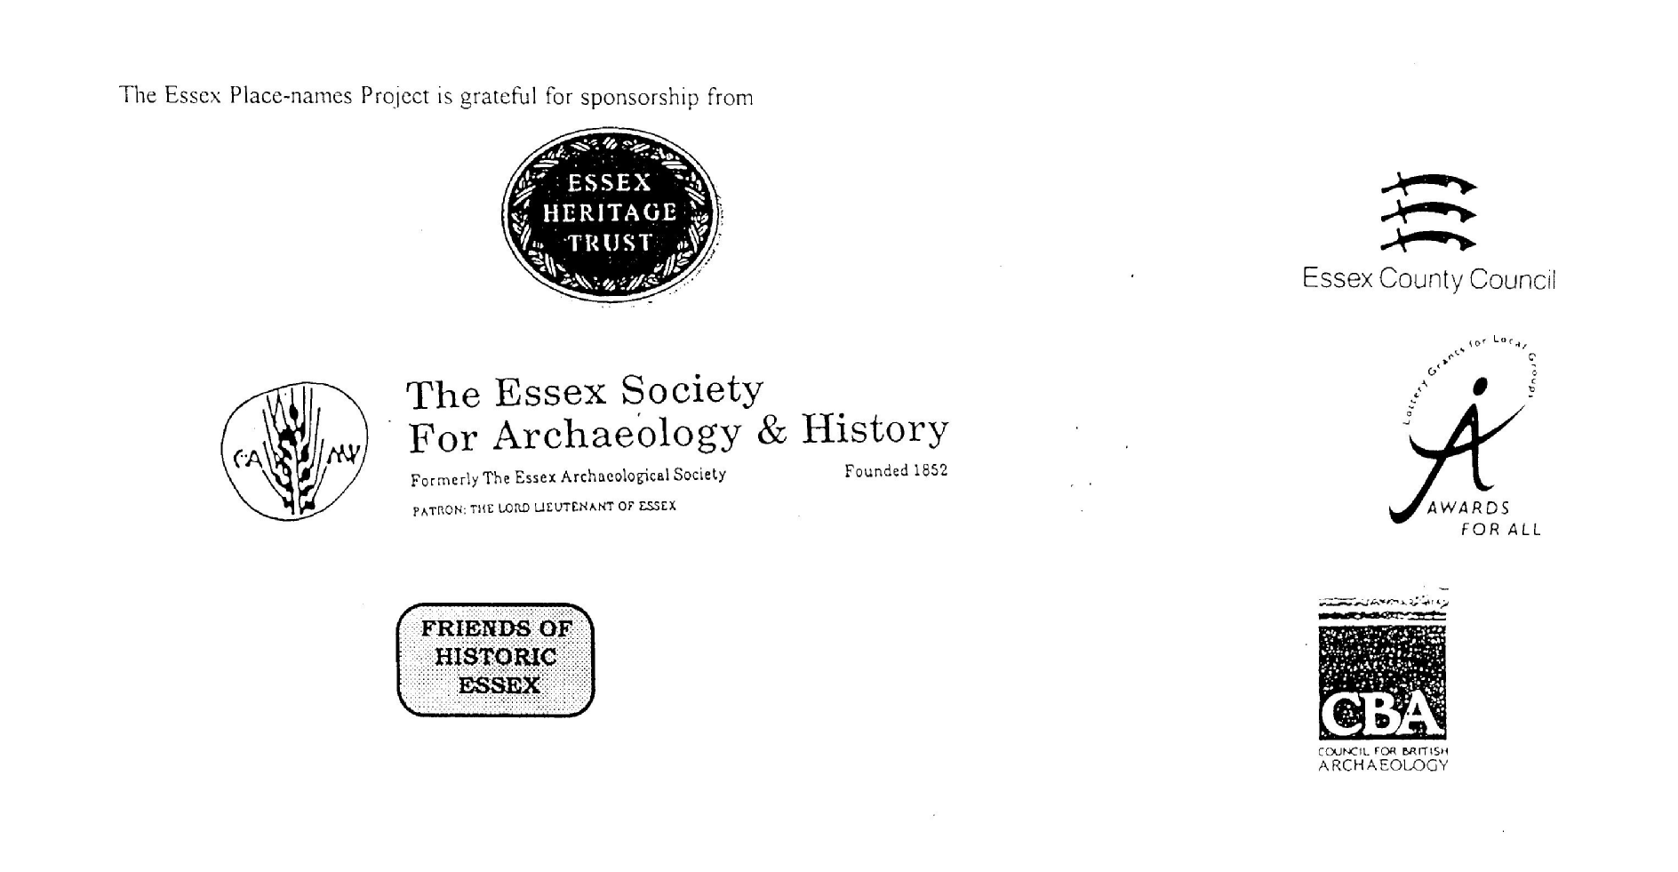

ESSEX PLACE-NAMES PROJECT.

The Essex Place-names Project is a County-wide survey to record place- and field-names from historical documents such as Tithe maps and apportionments, estate maps, sale
and auction catalogues, conveyances, terriers, deeds, rolls, inquisitions and surveys.

The second element of the Project is to investigate on-the-ground visible remains which correspond to the Place-names for actual or potential archaeological, agricultural and industrial
sites, and to record natural (topographical) and man-made features which may relate to the Place-name. This involves field-survey in rural and outside investigation in built-up areas.

It is anticipated that the Project will lead to identification of archaeological sites and lost historic buildings; it will enable analysis of indicators of early settlement, land holding, agricultural and industrial practices of the County. It will refine the more precise meaning of descriptive words and elements used by earlier settlers as they gave names appropriate to the topography of the landscape of their time.

For convenience the surveys are based on the parish, recognising that present civil parish boundaries are not necessarily identical to former ecclesiastical boundaries. Local Recorders
are supplied with templates of Record Forms to ensure consistency of recording across the County, and forward completed forms to a Central Coordinator for transfer to a county
computer database which is available to researchers on the internet at www.essex.ac.uk/history/esah/essexplacenames, and updated periodically.

This publication presents part of the information recorded from the Tithe or Estate Award and Map, and from other documents for this parish. The full record is contained on the master
database at Essex County Council (Historic Environment Section) and on the (above) website. Parish books are available from the Publications Manager, Essex Record Office, Wharf Road, Chelmsford CM2 6YT, on disc or in hard copy or may be downloaded from the website link ‘Books’ on the Home page. Please notify errors to the Project Coordinator at the Essex Record Office.

THE TITHE MAP AND APPORTIONMENT.

Since medieval times a tenth of the produce of land and stock had been paid by landholders to the church. At the Dissolution of the Monasteries, the property of many religious houses,
including the right to collect tithes, passed into lay hands. The Tithe Commutation Act which received Royal assent on 13th August 1836 abolished a rent payable in kind and
substituted rent-charges apportioned on each plot or parcel. The tithe-rent payable was assessed on the average value of wheat, barley and oats and was to fluctuate with price movements.

The commutation could be by voluntary agreement between the local owners and payers or, if agreement failed, could be compulsorily imposed by commissioners. A Valuer was to be
appointed to apportion the rent of each parcel of land and tenants could deduct that rent-charge from their rent paid to the landlord. The task fell to the Tithe Commissioners to produce a
map and an Apportionment (Award). A large-scale survey was produced for over 70% of England and Wales in the following 9 years, and about another 8% up to 1855. Most of the
parishes in Essex were surveyed. The map scales vary. The Award records ownership, tenancy and land-use, field by field and parcel by parcel (often quoting the field name) with the
ground area and rent-charge.

Land that was tithe-free tends to be less accurately mapped and contains few if any of the details recorded for those parcels subject to tithe. Rights of way and roads also tend to be
neglected. Boundaries of the tithe areas are shown as are some natural features such as streams, ponds, gardens, greens and commons. Buildings are often shown coloured red if dwellings
or grey if not. Because the Award may have been agreed only some time after the map was finished, discrepancies occur between the two. Enclosure Awards, when extant, usually date to the 18th and early 19th centuries. J.Kemble.
Reproduced by permission
of Essex County Council.

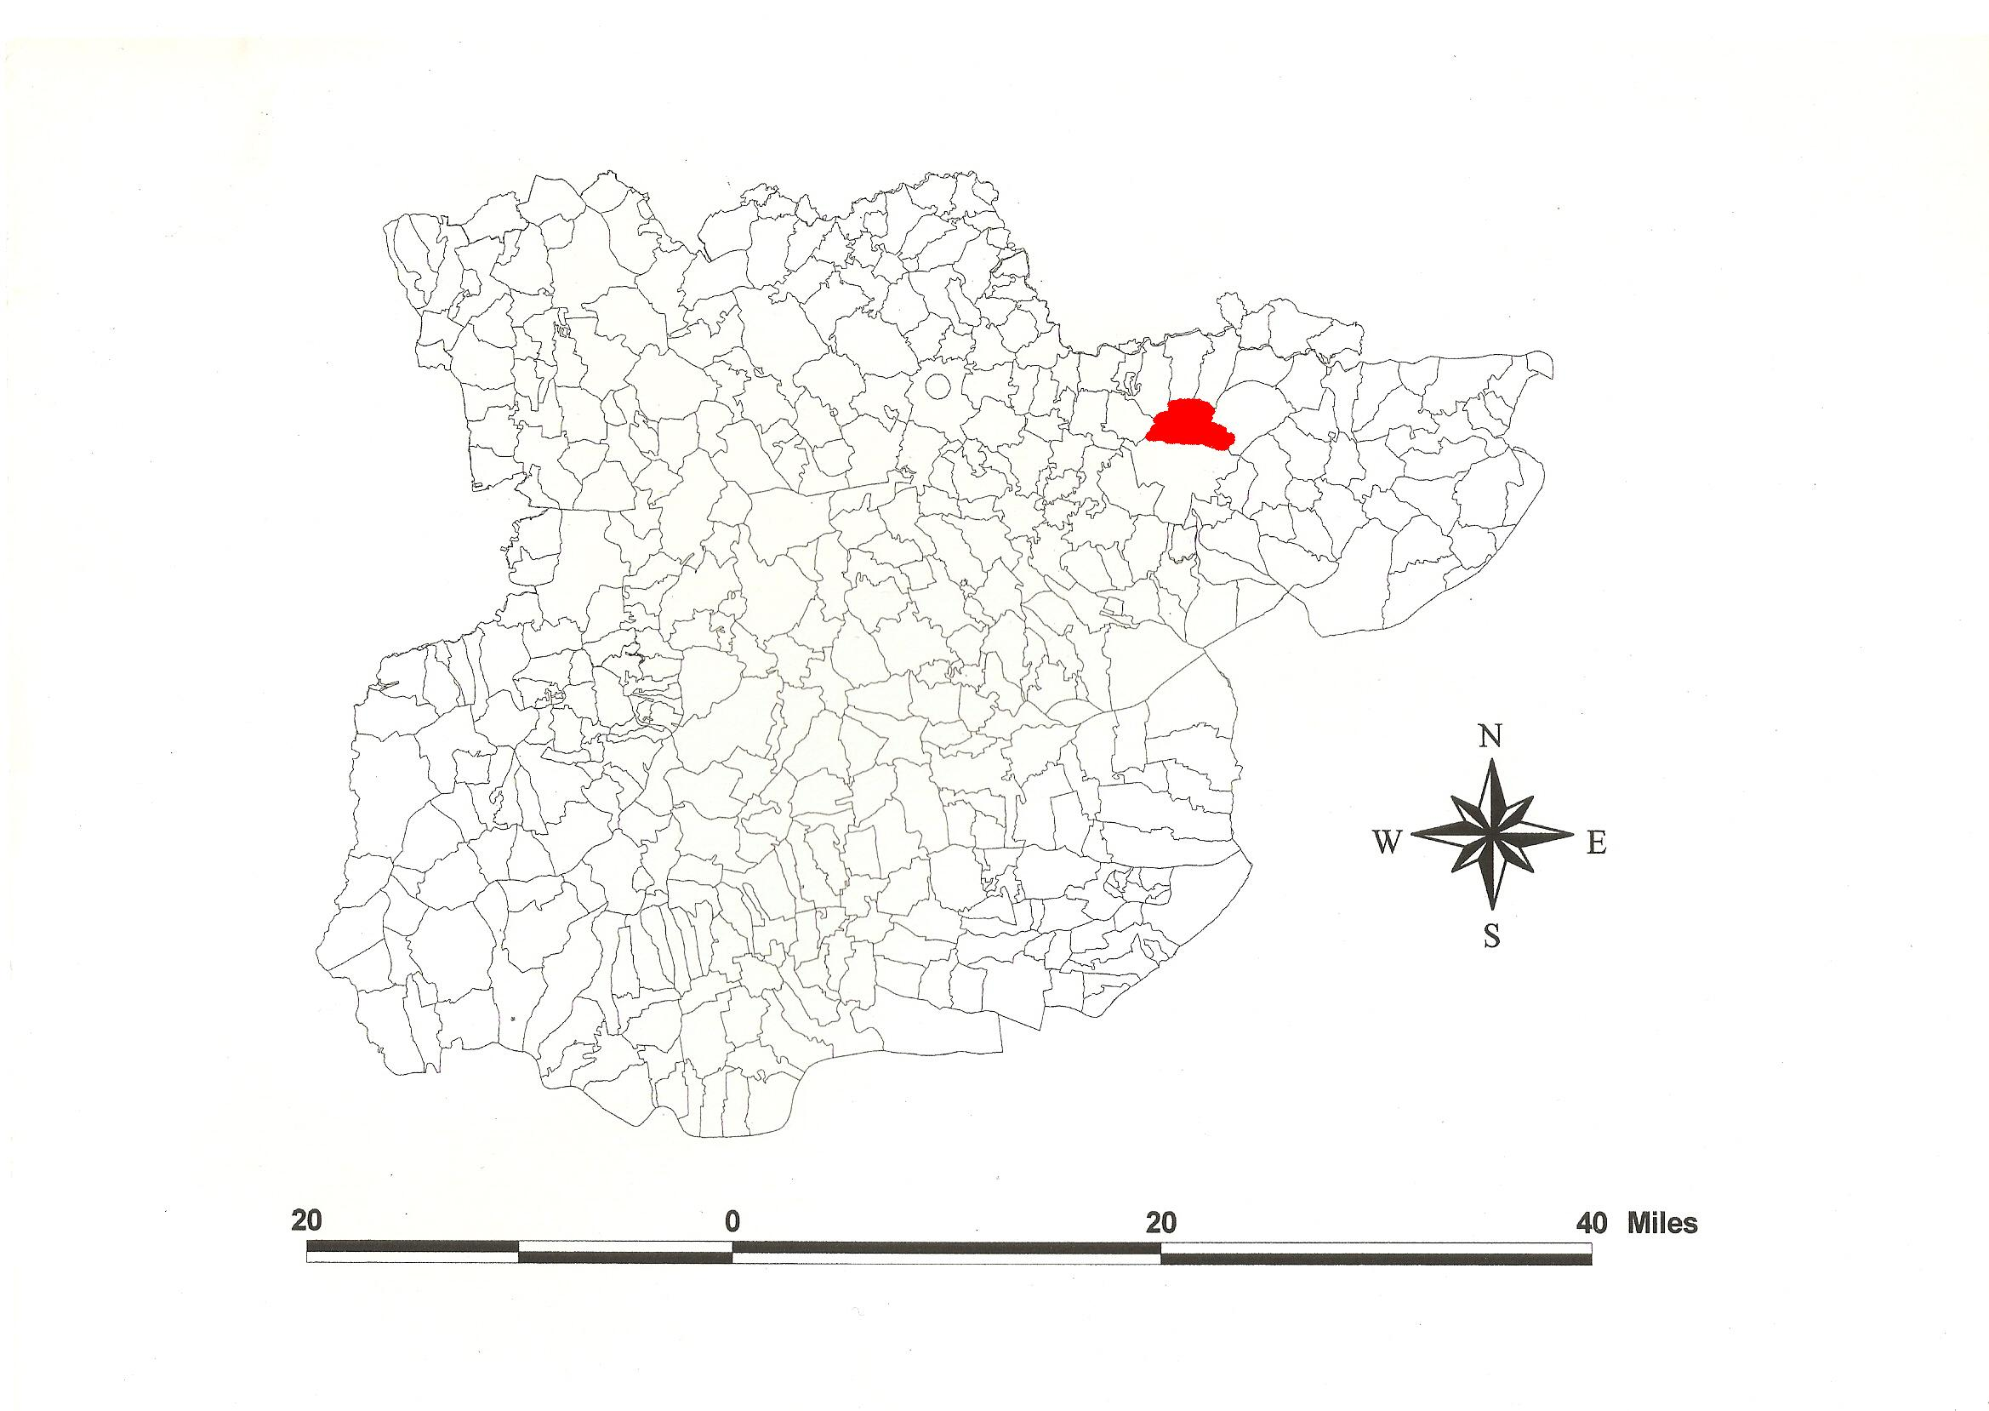
Mile End, Colchester, in the County of Essex.
Reproduced by permission
of Essex County Council.
Parish of Mile End, Colchester (in Lexden Hundred).

Colchester Mile End Tithe Award (Essex Record Office D/CT 242a), dated 1841, shows a rent-charge of £567-10-0 payable to Philip Strong, rector, including glebe of £7-10-0. The whole parish measured 2340 acres of which 2164 acres were subject to tithes. 1900 acres were arable, 145a meadow and pasture, 27a wood, 29a buildings. Exempt from tithes were land formerly of the dissolved abbey of St John 10 acres 2 roods 37 perches between High Wood and River Colne, High Wood 119a 3r 28p, Golden Grove 13a 2r 36p, and 34 acres 23 perches of part of East Wood, total exempt 176a 2r 3p. Glebe was 22a 36p. The Tithe Commissioners were William Blamire and J.W. Buller, the Valuers William Downes of Dedham and William Kendall Dawson of Colchester. The Tithe Map (ERO: D/CT 242b), dated 1842, was surveyed by Gilbert & Tayspill of Colchester at a scale of 13.3” to a mile and measures 37”x36”. It was countersigned by J.O. Martin, Assistant Tithe Commissioner.

Iron Age coins of Cunobelinus, c.5 BC - AD 40, were inscribed CAM(V) and CAMVL indicative of Camulodunum, ‘the fort of Camulos’, the war-god of the British. Cunobelin’s Farm was probably at Gosbecks, the site of the subsequent Romano-British temple. Colchester became the fort of the Roman army, then a veterans’ colony, colonia camulodunum, and appears in the 4th century Peutinger Table as Camuloduno. Ptolomy, c.AD 150, called it kaµouλoδouvov. The ‘modern’ name first appears in the Anglo-Saxon Chronicle, AD 921, as Colneceastre, probably from the British river name Colne + ceastre, camp. In Domesday Book, 1086, the Bishop of London had 14 houses and 4 acres at Colecestra, Westminster 2 houses, Barking Abbey 3 houses, St [R]Ouen Abbey 1 house taken by Waleran, Count Eustace 3 houses, and Ranulf Peverel 2 houses (Rivet, 1979; Morris, 1983; Kemble, 2007, 2009).

Mile End, Myland is documented as Milend, 1257, Feet of Fine, and La Milhende iuxta Colecestr’, 1285, Assize Rolls (Reaney, 1935), being a mile north of Colchester. It included the royal Forest of Kingswood (documented in 1168) which was granted to the burgesses of Colchester by Henry I or Stephen, the bounds perambulated in 1301 (Kemble, 2007). At Domesday, 1086, it may have been part of the holding of Count Eustace who held lands in Boxted to the north. As late as 1811, Mile End was deemed to be a ‘Liberty’ of Colchester, outside the Town, and separately taxed. In 1296 the four townships (villate) within the Liberty were Mile End, Greenstead, West Donyland (alias Berechurch) and Lexden. A charter of 1189 suggests that the Liberties (or banleuca) were in existance before that date, but Mile End was a parish by 1254, before which it had been part of St Peter’s parish, Colchester (VCH, 1907, Round, 1994). Mile End and Abbots Hall belonged to the community of St Osyth. In 1539 Henry VIII granted it to Thomas Cromwell, then after his fall, to John de Vere, earl of Oxford. Before 1556 it was bought by John Lucas. The rectory was in the gift of the prior of St Botolphs, then in t.Henry VIII it came to Sir Thomas Audley who sold it to John Lucas in 1551 (Morant, 1768; VCH, 1994).

The old church dedicated to St Michael, (remains in Rectory Close, TL 994265), to which the Tithe Award refers, was replaced in 1854 by a new one about half a mile further north. The Chapman & André map, 1777, shows it as having a tower. Myland Hall (now St Helena’s Hospice, TM 006273) is a two-bay C14 hall house with cross-wings (Pevsner, 2007; Jones, 2013).

The Hundred name was Lassendene, Laxendena, Lessendena etc in Domesday Book. The name is preceded by the estate Læxadyne in the Will of Ælfflæd, c.1000, widow of ealdorman Brihtnoth killed at the Battle of Maldon in 991 (Whitelock, 1930; Kemble, 2007). The Hundred Court was at Emperford alias Stanway Bridge (TL935241). The Domesday Hundred of Colchester was probably taken out of the older Lexden Hundred (Round, 1903). Reaney (1935) translates this perhaps ‘Leaxa’s valley’, lying as it does in the valley of River Colne.

References:

Jones, C., 2013. Finding Daniel Jones. Essex Journal , 48(ii), 61.
Kemble, J., 2007. Essex Place-names, Places, Streets & People, Historical Publications. pp 39, 47.
Kemble, J., 2009. Prehistoric & Roman Essex. History Press. p 127.
Morant, P., 1768. History & Antiquities of the County of Essex, i. 133.
Morris, J., 1983. Domesday Book – Essex. Phillimore.
Pevsner, N., Bettley, J., 2007. The Buildings of England – Essex. Yale.
Reaney, P., 1935. The Place-names of Essex. Cambridge.
Rivet, A., Smith, C., 1979. Place-names of Roman Britain. Batsford.
Round, H., 1994. The Liberties of Colchester. Essex Archaelogy & History, 25, 72.fs
Victoria County History of Essex. 1907, ii, 353. 1994, ix, 402.
Whitelock, D., 1930. Anglo-Saxon Wills. Cambridge.

The Tithe Place-names of Colchester Mile End - by Parcel No.

Place-name | Alias | Fld No | Grd Rf | x | y | Acr | rd | pch | Land use | Owner | Occupier | Other information
Benwells Meadow |  | 1 | TL | 995 | 259 | 3 | 2 | 38 | grass | Strong, Rev Philip | Howe, John | glebe
Benwells Field |  | 2 | TL | 995 | 260 | 2 | 3 | 5 | arable | Strong, Rev Philip | Howe, John | glebe
Garden Ground |  | 5 |  |  |  | 5 | 0 | 19 |  | Tucker, Rev Wm Marwood | Nash, John | glebe of All Saints
King's Meadow(piece in) |  | 7 |  |  |  | 2 | 1 | 25 | grass | Round, Charles Gray | Hills, Elizabeth
King's Meadow(piece in) |  | 8 |  |  |  | 0 | 3 | 35 | grass | Chopping, Isaac | Chopping, Isaac
King's Meadow(piece in) |  | 11 | TL | 997 | 259 | 2 | 1 | 20 | grass | Mercers Company | Dennis, George
King's Meadow(piece in) |  | 13 |  |  |  | 1 | 1 | 22 | . | Carr, Rev Samuel | Hills, Elizabeth | glebe of St Peter
King's Meadow(piece in) |  | 16 |  |  |  | 0 | 2 | 38 | grass | Springett, Harry | Chignell, William
King's Meadow(piece in) |  | 17 |  |  |  | 1 | 0 | 35 | grass | Haynes, David Avery Bell | Hills, Elizabeth
Pond field |  | 21 |  |  |  | 13 | 0 | 2 | arable | Mercers Company | Dennis, George
Homestead | Mercer's Farm, 1875,OS | 23 | TL | 998 | 261 | 0 | 3 | 15 |  | Mercers Company | Dennis, George
Market Garden, House |  | 30 |  |  |  | 5 | 3 | 18 | gdnground | Bunting, Isaac | Bunting, William
Homestead | Poplarhall Farm, 1875,OS | 36 | TL | 994 | 263 | 0 | 3 | 23 |  | Ward, Rev Wm Henry Percival | Partridge, William
Brick yard, sheds |  | 40 | TL | 996 | 264 | 2 | 1 | 12 |  | Alston, Richard | Alston, Richard
White Hart field |  | 41 |  |  |  | 7 | 1 | 18 | arable | Strong, Rev Philip | Ambrose, John | glebe
White Hart Meadow |  | 43 |  |  |  | 1 | 2 | 39 | grass | Strong, Rev Philip | Strong, Rev Philip | glebe
Lower Hedge Downs |  | 45 |  |  |  | 7 | 3 | 5 | arable | De Grey, Earl | Ambrose, John
Twisted field |  | 46 |  |  |  | 4 | 0 | 27 | arable | Free Grammar School, Colchester, trustees | Ambrose, John
Upper Hedge Downs |  | 47 |  |  |  | 3 | 2 | 27 | arable | De Grey, Earl | Ambrose, John
Brick field (pt) |  | 48 | TL | 997 | 265 | 1 | 1 | 20 | arable | Ward, Rev Wm Henry Percival | Partridge, William
Brick Pits, sheds |  | 49 |  |  |  | 3 | 1 | 20 |  | Ward, Rev Wm Henry Percival | Partridge, William
Brick field (pt) |  | 50 | TL | 997 | 266 | 6 | 3 | 27 | arable | Ward, Rev Wm Henry Percival | Partridge, William
Upper Scotland |  | 51 |  |  |  | 4 | 3 | 15 | arable | Carr, Rev Samuel | Dennis, Wm Gentry | glebe of St Peter
Lower Scotland |  | 52 |  |  |  | 5 | 0 | 18 | arable | Carr, Rev Samuel | Dennis, Wm Gentry | glebe of St Peter
Barkers Land |  | 53 |  |  |  | 21 | 0 | 2 | arable | De Grey, Earl | Clay, John
Partridge Fen |  | 57 |  |  |  | 0 | 3 | 22 | grass | Mercers Company | Dennis, George
Great Netherlands |  | 58 | TM | 003 | 262 | 17 | 0 | 4 | arable | De Grey, Earl | Clay, John | cut by railway, 1875,OS
Great Hook field |  | 59 |  |  |  | 15 | 2 | 33 | arable | De Grey, Earl | Clay, John
Little Hook field |  | 60 | TM | 004 | 263 | 10 | 2 | 15 | arable | De Grey, Earl | Clay, John | cut by railway, 1875,OS
Poach Meadow (pt) |  | 61 |  |  |  | 4 | 1 | 32 | grass | De Grey, Earl | Clay, John
Woodcock Downs (pt) |  | 62 |  |  |  | 12 | 2 | 28 | arable | De Grey, Earl | Clay, John
Farthing Bottom |  | 63 | TM | 002 | 266 | 7 | 0 | 34 | arable | De Grey, Earl | Dennis, Wm Gentry | Walter Ferthing, 1295,ParlR
Boat field |  | 66 |  |  |  | 22 | 3 | 32 | arable | De Grey, Earl | Dennis, Wm Gentry
Great Stock |  | 67 |  |  |  | 14 | 0 | 14 | arable | De Grey, Earl | Dennis, Wm Gentry
Old Ley |  | 68 |  |  |  | 15 | 3 | 27 |  | De Grey, Earl | Dennis, Wm Gentry
Long Meadow |  | 70 |  |  |  | 2 | 0 | 18 | arable | De Grey, Earl | Dennis, Wm Gentry
Hilly field |  | 71 |  |  |  | 2 | 2 | 12 | grass | De Grey, Earl | Dennis, Wm Gentry
Pound field |  | 73 | TM | 005 | 270 | 6 | 0 | 31 | arable | De Grey, Earl | Dennis, Wm Gentry
Great East field (pt) |  | 74 |  |  |  | 20 | 2 | 9 | arable | De Grey, Earl | Dennis, Wm Gentry
East Wood (pt) |  | 77 | TM | 010 | 273 | 34 | 0 | 23 | wood | De Grey, Earl | De Grey, Earl | Tithe exempt, formerly of St Johns Abbey
Orchard field |  | 78 |  |  |  | 4 | 3 | 36 | arable | De Grey, Earl | Dennis, Wm Gentry
Homestead | Milend, 1257,FF; Mylende, 1291, For; Mile-end Hall, 1875,OS | 80 | TM | 006 | 273 | 1 | 1 | 4 | grass | De Grey, Earl | Dennis, Wm Gentry
Barn field |  | 81 |  |  |  | 4 | 0 | 36 | grass | De Grey, Earl | Dennis, Wm Gentry
Mare Hill |  | 83 |  |  |  | 4 | 3 | 4 | arable | De Grey, Earl | Dennis, Wm Gentry
Sandpit field |  | 85 | TM | 003 | 274 | 14 | 2 | 6 | arable | De Grey, Earl | Dennis, Wm Gentry
Garden field |  | 86 |  |  |  | 14 | 2 | 39 | arable | De Grey, Earl | Dennis, Wm Gentry
Hatches |  | 87 |  |  |  | 17 | 1 | 29 | arable | De Grey, Earl | Dennis, Wm Gentry
High Wood |  | 88 | TM | 001 | 273 | 119 | 3 | 28 | wood | De Grey, Earl | De Grey, Earl | Tithe exempt, formerly of St Johns Abbey
Six Acre Johnsons |  | 89 |  |  |  | 6 | 0 | 8 | arable | Mayor,Aldermen, Burgesses of Colchester | Cant, Wm, late, execs
Cottage, gdn |  | 90 |  |  |  | 0 | 1 | 35 |  | Ambrose, John | Ambrose, John
Nineteen Acres |  | 92 | TL | 996 | 272 | 19 | 1 | 29 | arable | Charity Land (St Mary's) | Smith, JOhn
Wood field |  | 95 | TL | 998 | 270 | 8 | 2 | 2 | arable | Ward, Rev Wm Henry Percival | Partridge, William
White Hart field |  | 96 | TL | 998 | 269 | 6 | 3 | 10 | arable | De Grey, Earl | Dennis, Wm Gentry
Scollop Green field |  | 97 |  |  |  | 3 | 2 | 18 | arable | Free Grammar School, Colchester, trustees | Ambrose, John
Parsonage Lawn |  | 100 | TL | 996 | 266 | 3 | 3 | 32 | grass | Strong, Rev Philip | Strong, Rev Philip | glebe
Lodge, gdn |  | 101 |  |  |  | 0 | 1 | 5 |  | Strong, Rev Philip | Strong, Rev Philip | glebe
Rectory, premises |  | 102 | TL | 993 | 266 | 1 | 2 | 7 |  | Strong, Rev Philip | Strong, Rev Philip | glebe
Church & yd | St Michaels, Remains of, 1875,OS | 103 | TL | 993 | 266 | 0 | 0 | 35 |  | Strong, Rev Philip | Strong, Rev Philip | glebe
Homestead |  | 104 |  |  |  | 0 | 3 | 11 |  | De Grey, Earl | Ambrose, John
Grove field |  | 107 | TL | 994 | 268 | 5 | 0 | 26 | arable | De Grey, Earl | Ambrose, John
Hanging field |  | 108 | TL | 994 | 270 | 3 | 1 | 4 | arable | De Grey, Earl | Ambrose, John
Pond field |  | 109 | TL | 993 | 270 | 4 | 2 | 27 | arable | De Grey, Earl | Ambrose, John
Little Brook field |  | 111 |  |  |  | 3 | 0 | 10 | arable | De Grey, Earl | Ambrose, John
Eight Acre Pond field |  | 112 | TL | 991 | 270 | 8 | 3 | 34 | arable | De Grey, Earl | Ambrose, John
Barn field |  | 113 |  |  |  | 4 | 1 | 15 | arable | De Grey, Earl | Ambrose, John
Barn field |  | 115 |  |  |  | 9 | 1 | 37 | arable | Tillett, James | Tillett, James
Little Chequer field |  | 119 |  |  |  | 2 | 1 | 18 | arable | Tillett, James | Tillett, James
Great Chequer field |  | 120 | TL | 990 | 268 | 5 | 2 | 36 | arable | Tillett, James | Tillett, James
Great Hilly field |  | 126 |  |  |  | 4 | 2 | 9 | arable | Green, Hugh | Stannard, William
Little Hilly field |  | 127 |  |  |  | 1 | 3 | 36 | arable | Green, Hugh | Stannard, William
Potters field |  | 128 | TL | 988 | 269 | 9 | 2 | 34 | arable | Aubert, John Daniel | Wright, John
Gallow field |  | 131 | TL | 983 | 271 | 7 | 1 | 11 | arable | Aubert, John Daniel | Wright, John
Stub field |  | 133 |  |  |  | 4 | 1 | 12 | arable | Aubert, John Daniel | Wright, John
Round field |  | 134 |  |  |  | 5 | 3 | 12 | arable | Aubert, John Daniel | Wright, John
Broom field |  | 135 |  |  |  | 7 | 0 | 35 | arable | Aubert, John Daniel | Wright, John
Further Stable field |  | 137 |  |  |  | 4 | 3 | 22 | arable | Aubert, John Daniel | Wright, John
Homestead | Braiswick Farm, 1875,OS | 138 | TL | 986 | 276 | 1 | 3 | 25 |  | Aubert, John Daniel | Wright, John | Thomas de Bray, 1258,M
Long Pightle |  | 145 |  |  |  | 1 | 1 | 1 | arable | Green, Hugh | Stannard, William
Homestead | Myland Lodge, 1875,OS | 146 | TL | 989 | 275 | 1 | 1 | 14 |  | Green, Hugh | Stannard, William
Barn field |  | 147 |  |  |  | 1 | 3 | 16 | arable | Green, Hugh | Stannard, William
Hither Pightle |  | 149 |  |  |  | 1 | 2 | 24 | arable | Green, Hugh | Stannard, William
Brook Meadow |  | 152 | TL | 990 | 274 | 2 | 3 | 0 | grass | Green, Hugh | Stannard, William
Brook field |  | 154 |  |  |  | 2 | 3 | 32 | arable | Green, Hugh | Stannard, William
Allotment field |  | 155 |  |  |  | 5 | 3 | 25 | arable | De Grey, Earl | De Grey, Earl
Brook field |  | 157 |  |  |  | 4 | 1 | 12 | grass | De Grey, Earl | Roofe, Charles Bell
Long field |  | 161 |  |  |  | 5 | 2 | 17 | grass | De Grey, Earl | Roofe, Charles Bell
Barn Pightle |  | 163 |  |  |  | 1 | 0 | 28 | grass | De Grey, Earl | Roofe, Charles Bell
Homestead | Lane Farm, 1875,OS | 164 | TL | 991 | 276 | 0 | 1 | 39 |  | De Grey, Earl | Roofe, Charles Bell
Pond piece |  | 165 |  |  |  | 0 | 2 | 0 |  | De Grey, Earl | Roofe, Charles Bell
Paddock |  | 166 |  |  |  | 1 | 2 | 10 | grass | De Grey, Earl | Roofe, Charles Bell
Homestead | Tubbeswick, 1348,MC; Tubbswick Farm, 1875,OS | 169 | TL | 991 | 277 | 1 | 1 | 32 |  | Burgesses of Borough of Colchester | Cant, Wm, late, execs | Richard Tubbe, bailiff of Colchester, 1296/7
Pightle |  | 170 |  |  |  | 2 | 2 | 9 | arable | Mayor,Aldermen, Burgesses of Colchester | Cant, Wm, late, execs
Further Road field |  | 171 |  |  |  | 2 | 3 | 18 | arable | Auston, Susan | Shairp, George
First Road field |  | 173 | TL | 995 | 278 | 3 | 2 | 12 | arable | Auston, Susan | Shairp, George
Homestead | Holly Farm, 1875,OS | 174 | TL | 996 | 277 | 0 | 2 | 21 |  | Auston, Susan | Shairp, George
House field |  | 175 |  |  |  | 2 | 1 | 25 | arable | Auston, Susan | Shairp, George
Barn field |  | 176 |  |  |  | 3 | 3 | 3 | arable | Auston, Susan | Shairp, George
Orchard field |  | 177 |  |  |  | 4 | 0 | 30 | arable | Auston, Susan | Shairp, George
Grip field |  | 178 |  |  |  | 4 | 0 | 34 | arable | Auston, Susan | Shairp, George
Golden Grove |  | 180 | TL | 994 | 272 | 13 | 2 | 35 | wood | De Grey, Earl | De Grey, Earl | Tithe exempt, formerly of St Johns Abbey
Loveney |  | 181 | TL | 996 | 274 | 3 | 1 | 37 | arable | Charity Land (St Mary's) | Smith, JOhn
Golden Acre |  | 182 |  |  |  | 0 | 3 | 37 | arable | Mayor,Aldermen, Burgesses of Colchester | Cant, Wm, late, execs
Cottage, gdn |  | 183 |  |  |  | 0 | 0 | 28 |  | Ambrose, John | Gibbons, William | Tithe exempt
Johnsons |  | 185 | TL | 998 | 276 | 3 | 1 | 36 | arable | Mayor,Aldermen, Burgesses of Colchester | Cant, Wm, late, execs
Tubswick | cp. Tubbeswick, 1328,MC | 186 | TL | 999 | 277 | 5 | 2 | 37 | arable | Mayor,Aldermen, Burgesses of Colchester | Cant, Wm, late, execs
Tile field |  | 188 | TM | 000 | 280 | 12 | 1 | 18 | arable | De Grey, Earl | Ambrose, John
Clay Pits |  | 189 |  |  |  | 3 | 1 | 6 | arable | De Grey, Earl | Ambrose, John
Shrubbs |  | 190 | TL | 999 | 278 | 11 | 1 | 0 | arable | De Grey, Earl | Ambrose, John
Homestead |  | 191 | TL | 998 | 278 | 0 | 2 | 1 |  | De Grey, Earl | Ambrose, John
Homestead |  | 193 |  |  |  | 0 | 0 | 29 |  | De Grey, Earl | Ambrose, John
Orchard |  | 194 |  |  |  | 1 | 0 | 5 | grass | De Grey, Earl | Ambrose, John
Garden Piece |  | 195 |  |  |  | 0 | 3 | 15 |  | Philbrick, Frederick Bloomfield | Philbrick, Frederick Bloomfield
Cottages, gdns |  | 197 |  |  |  | 0 | 2 | 2 |  | Hale, William | Hale, William
Cottage, gdn |  | 200 |  |  |  | 0 | 0 | 18 |  | Maldon, Charles | Maldon, Charles | Tithe exempt
Grass Piece |  | 203 |  |  |  | 0 | 2 | 6 | grass | Shairp, George | Shairp, George
Potters field |  | 204 |  |  |  | 5 | 2 | 12 | arable | Shairp, George | Shairp, George
Mill field |  | 205 | TL | 998 | 279 | 3 | 3 | 36 | arable | Shairp, George | Shairp, George
House, gdn | Mill House, 1875,OS | 207 | TL | 999 | 280 | 0 | 2 | 99 |  | Shairp, George | Shairp, George
Great Brinkley | cp. Brinckley farme, 1722,MC | 210 | TM | 000 | 280 | 9 | 1 | 22 | arable | Mayor,Aldermen, Burgesses of Colchester | Shairp, George
Little Brinkley |  | 211 |  |  |  | 2 | 3 | 33 | arable | Mayor,Aldermen, Burgesses of Colchester | Shairp, George
Heath piece |  | 212 | TM | 000 | 281 | 3 | 1 | 5 | arable | Mayor,Aldermen, Burgesses of Colchester | Shairp, George
Cottage, gdn |  | 215 |  |  |  | 0 | 3 | 25 |  | Gunner, Samuel | Gunner, Samuel
Heath field | [Mile-end Heath, 1777,C] | 219 | TL | 999 | 282 | 2 | 3 | 28 | furze | Mayor,Aldermen, Burgesses of Colchester | Tillett, Isaac
Gamekeeper's House, gdn | [Mile-end Heath, 1777,C] | 224 | TL | 998 | 285 | 1 | 1 | 13 |  | Mayor,Aldermen, Burgesses of Colchester | Hale, William
Ten Acre Mill field | [Mile-end Heath, 1777,C] | 226 | TL | 997 | 282 | 9 | 3 | 6 | arable | Mayor,Aldermen, Burgesses of Colchester | Cant, Wm, late, execs
Home Ten Acres |  | 231 | TL | 992 | 277 | 9 | 3 | 16 | arable | Mayor,Aldermen, Burgesses of Colchester | Cant, Wm, late, execs
Blacksmiths field |  | 232 | TL | 991 | 277 | 3 | 1 | 13 | arable | Mayor,Aldermen, Burgesses of Colchester | Cant, Wm, late, execs
Cottage, Beer shop, gdn |  | 234 |  |  |  | 0 | 2 | 26 |  | Smith, John | Smith, John
Cottage, gdn, smithy |  | 240 |  |  |  | 0 | 1 | 14 |  | Daniels, Thomas | Seaborn, Robert
Ranters Meeting House |  | 241 | TL | 989 | 280 | 0 | 0 | 3 |  | .. | .. | Tithe exempt
House, sheds, gdn |  | 249 |  |  |  | 0 | 3 | 33 |  | Smith, John (Farmer) | Smith, John (Farmer)
Dog & Pheasant Inn |  | 254 | TL | 990 | 277 | 0 | 2 | 4 | inn | Ward, James | Thompson, Thomas
Cottage, barn |  | 261 |  |  |  | 0 | 0 | 11 |  | Mayor,Aldermen, Burgesses of Colchester | Newson, Mary Ann
Carpet field |  | 267 |  |  |  | 6 | 1 | 17 | arable | Aubert, John Daniel | Wright, John
Kiln Field |  | 268 | TL | 984 | 275 | 4 | 2 | 21 | arable | Aubert, John Daniel | Wright, John
Middle field |  | 269 |  |  |  | 5 | 3 | 20 | arable | Aubert, John Daniel | Wright, John
Long Four Acres |  | 270 | TL | 983 | 275 | 4 | 2 | 0 | arable | Aubert, John Daniel | Wright, John
Wicker field |  | 272 | TL | 982 | 280 | 5 | 0 | 7 | arable | Aubert, John Daniel | Wright, John
Cole-earth field |  | 273 | TL | 983 | 280 | 5 | 3 | 20 | arable | Aubert, John Daniel | Wright, John
Cottage, gdn |  | 279 |  |  |  | 1 | 1 | 20 |  | Mayor,Aldermen, Burgesses of Colchester | Dixey, samuel
Old Wood |  | 283 | TL | 982 | 282 | 10 | 1 | 31 | arable | Cooke, Samuel Green | Ford, Elizabeth
Horksley meadow |  | 287 | TL | 980 | 286 | 2 | 2 | 36 | grass | Cooke, Samuel Green | Ford, Elizabeth
Kiln Field |  | 288 | TL | 982 | 286 | 6 | 3 | 6 | arable | Cooke, Samuel Green | Ford, Elizabeth
Wood |  | 289 | TL | 983 | 285 | 3 | 3 | 23 | wood | Cooke, Samuel Green | Ford, Elizabeth
New England |  | 292 |  |  |  | 2 | 1 | 26 | arable | Aubert, John Daniel | Ford, Elizabeth
Stoney field (pt) |  | 295 | TL | 986 | 285 | 4 | 0 | 34 | arable | Aubert, John Daniel | Ford, Elizabeth
Old Fouls |  | 299 | TL | 986 | 284 | 1 | 0 | 8 | grass | Aubert, John Daniel | Ford, Elizabeth
Old Barn Yard |  | 300 | TL | 988 | 282 | 1 | 2 | 35 | grass | Aubert, John Daniel | Ford, Elizabeth
Old Orchard |  | 303 | TL | 988 | 283 | 2 | 0 | 18 | arable | Aubert, John Daniel | Ford, Elizabeth
Over Road field |  | 304 | TL | 988 | 284 | 6 | 2 | 20 | arable | Aubert, John Daniel | Ford, Elizabeth
Slip |  | 306 |  |  |  | 0 | 3 | 29 | arable | Aubert, John Daniel | Ford, Elizabeth
Grove field |  | 308 | TL | 999 | 285 | 2 | 2 | 1 | arable | Aubert, John Daniel | Ford, Elizabeth
Black field (pt) |  | 309 |  |  |  | 1 | 3 | 25 | arable | Aubert, John Daniel | Ford, Elizabeth
Homestead | Chapman's Farm, 1875,OS | 315 | TL | 999 | 284 | 1 | 0 | 25 |  | Aubert, John Daniel | Ford, Elizabeth
Homestead | Mile-end Lodge, 1875,OS | 316 | TL | 999 | 283 | 0 | 2 | 3 |  | Aubert, John Daniel | Ford, Elizabeth
Cottage, gdn |  | 317 |  |  |  | 0 | 3 | 6 |  | Barnes, John Stuck | Barnes, John Stuck
Corner Pightle |  | 319 |  |  |  | 0 | 2 | 31 | arable | Barnes, widow | Garwood, John
Pond field |  | 322 |  |  |  | 2 | 3 | 18 | arable | Mayor,Aldermen, Burgesses of Colchester | Bugg, William
Pound field |  | 323 |  |  |  | 3 | 0 | 34 | arable | Mayor,Aldermen, Burgesses of Colchester | Bugg, William
Old field |  | 324 |  |  |  | 1 | 1 | 32 | arable | Mayor,Aldermen, Burgesses of Colchester | Bugg, William
Homestead |  | 326 |  |  |  | 0 | 1 | 38 |  | Mayor,Aldermen, Burgesses of Colchester | Bugg, William
Cottage field |  | 327 |  |  |  | 2 | 0 | 31 | arable | Mayor,Aldermen, Burgesses of Colchester | Bugg, William
Back field |  | 330 |  |  |  | 3 | 2 | 25 | arable | Mayor,Aldermen, Burgesses of Colchester | Bugg, William
Cottage, & field |  | 334 |  |  |  | 2 | 0 | 22 | arable | Mayor,Aldermen, Burgesses of Colchester | Ramsey, Mary
No name |  | 342 |  |  |  | 3 | 0 | 26 | arable | Mayor,Aldermen, Burgesses of Colchester | Garwood, John
Cottage, gdn |  | 347 |  |  |  | 0 | 0 | 28 |  | Mayor,Aldermen, Burgesses of Colchester | Smith, John
Short Lane |  | 349 |  |  |  | 1 | 3 | 6 | grass | Mayor,Aldermen, Burgesses of Colchester | Smith, John
Long Bottom |  | 355 | TL | 991 | 291 | 1 | 0 | 8 | arable | Mayor,Aldermen, Burgesses of Colchester | Smith, John
Shaves meadow |  | 357 | TL | 992 | 293 | 5 | 2 | 39 | arable | Mayor,Aldermen, Burgesses of Colchester | Wyncoll, William
Cottage, barn, yd | Cuckoo Farm, 1875,OS | 360 | TL | 991 | 291 | 0 | 1 | 1 |  | Mayor,Aldermen, Burgesses of Colchester | Wyncoll, William
Eleven acres |  | 370 |  |  |  | 11 | 1 | 27 | arable | Mayor,Aldermen, Burgesses of Colchester | Wyncoll, William
White House field |  | 371 |  |  |  | 5 | 1 | 18 | arable | Mayor,Aldermen, Burgesses of Colchester | Tillett, Isaac
Six acres |  | 380 | TL | 999 | 288 | 6 | 1 | 15 | arable | Mayor,Aldermen, Burgesses of Colchester | Blyth, Samuel Blomfield
Homestead | Whitehouse Farm, 1875,OS | 383 | TM | 001 | 293 | 1 | 1 | 5 |  | Mayor,Aldermen, Burgesses of Colchester | Blyth, Samuel Blomfield
Stable field |  | 384 |  |  |  | 14 | 0 | 13 | arable | Mayor,Aldermen, Burgesses of Colchester | Blyth, Samuel Blomfield
Kitchen field |  | 385 |  |  |  | 9 | 1 | 30 | arable | Mayor,Aldermen, Burgesses of Colchester | Blyth, Samuel Blomfield
Further Boxted Piece |  | 387 | TM | 005 | 294 | 9 | 1 | 31 | arable | Mayor,Aldermen, Burgesses of Colchester | Folkard, John
Cottage, gdn |  | 388 |  |  |  | 0 | 0 | 34 |  | Mayor,Aldermen, Burgesses of Colchester | Sadler, Isaac | Tithe exempt
Hither Wood Piece |  | 391 |  |  |  | 10 | 2 | 13 | arable | Mayor,Aldermen, Burgesses of Colchester | Blyth, Samuel Blomfield
The Grove |  | 392 | TM | 002 | 290 | 4 | 1 | 0 | arable | Mayor,Aldermen, Burgesses of Colchester | Blyth, Samuel Blomfield
Stump Stile field |  | 395 |  |  |  | 5 | 0 | 0 | arable | Mayor,Aldermen, Burgesses of Colchester | Howlet, Henry Watkinson
Pump field |  | 400 | TM | 003 | 295 | 7 | 3 | 24 | arable | Mayor,Aldermen, Burgesses of Colchester | Howlet, Henry Watkinson
Homestead | Old Heath Farm, 1875,OS | 402 | TM | 003 | 294 | 1 | 0 | 24 |  | Mayor,Aldermen, Burgesses of Colchester | Howlet, Henry Watkinson
Pond field |  | 405 |  |  |  | 4 | 2 | 32 | arable | Mayor,Aldermen, Burgesses of Colchester | Howlet, Henry Watkinson
Barn field |  | 406 |  |  |  | 3 | 2 | 17 | arable | Mayor,Aldermen, Burgesses of Colchester | Howlet, Henry Watkinson
Six Acre Brinkley |  | 407 |  |  |  | 6 | 1 | 23 | arable | Mayor,Aldermen, Burgesses of Colchester | Howlet, Henry Watkinson
Five Acre Brinkley |  | 408 |  |  |  | 5 | 1 | 35 | arable | Mayor,Aldermen, Burgesses of Colchester | Howlet, Henry Watkinson
Eight Acre Brinkley |  | 409 | TM | 007 | 281 | 8 | 3 | 5 | arable | Mayor,Aldermen, Burgesses of Colchester | Howlet, Henry Watkinson
Five Acre Ley |  | 410 |  |  |  | 4 | 2 | 2 | arable | Mayor,Aldermen, Burgesses of Colchester | Howlet, Henry Watkinson
Pointers Piece |  | 412 |  |  |  | 1 | 2 | 30 | arable | Mayor,Aldermen, Burgesses of Colchester | Howlet, Henry Watkinson
Garden field |  | 413 |  |  |  | 5 | 1 | 13 | arable | Mayor,Aldermen, Burgesses of Colchester | Howlet, Henry Watkinson
Hop Field |  | 414 |  |  |  | 6 | 2 | 7 | arable | Mayor,Aldermen, Burgesses of Colchester | Belsham, Isaac
Great Poor Piece |  | 415 |  |  |  | 5 | 3 | 17 | arable | Mayor,Aldermen, Burgesses of Colchester | Belsham, Isaac
Little Poor Piece |  | 416 |  |  |  | 3 | 1 | 5 | arable | Mayor,Aldermen, Burgesses of Colchester | Belsham, Isaac
Wood Piece |  | 417 |  |  |  | 4 | 3 | 13 | arable | Mayor,Aldermen, Burgesses of Colchester | Belsham, Isaac
Stone Pightle |  | 420 |  |  |  | 1 | 0 | 18 | arable | Mayor,Aldermen, Burgesses of Colchester | Belsham, Isaac
House, gdn |  | 421 |  |  |  | 0 | 0 | 22 |  | Mayor,Aldermen, Burgesses of Colchester | Belsham, Isaac
Barn Pightle |  | 422 | TM | 008 | 289 | 2 | 1 | 28 | arable | Mayor,Aldermen, Burgesses of Colchester | Belsham, Isaac
Boxted field |  | 428 |  |  |  | 9 | 1 | 22 | arable | Mayor,Aldermen, Burgesses of Colchester | Johnson, Sarah
Barn field |  | 429 |  |  |  | 8 | 3 | 0 | arable | Mayor,Aldermen, Burgesses of Colchester | Johnson, Sarah
Homestead | Kingswood Heath or the Severalls, 1722, MC; Severalls Hall, 1875,OS | 430 | TM | 008 | 290 | 1 | 1 | 35 |  | Mayor,Aldermen, Burgesses of Colchester | Johnson, Sarah
Long field |  | 432 |  |  |  | 5 | 0 | 16 | arable | Mayor,Aldermen, Burgesses of Colchester | Johnson, Sarah
Banter field |  | 435 | TM | 010 | 289 | 10 | 1 | 14 | arable | Mayor,Aldermen, Burgesses of Colchester | Johnson, Sarah
Seven acres |  | 438 |  |  |  | 8 | 2 | 3 | arable | Mayor,Aldermen, Burgesses of Colchester | King, James
Long Ten acres |  | 443 | TM | 008 | 285 | 9 | 3 | 4 | arable | Mayor,Aldermen, Burgesses of Colchester | Johnson, Sarah
No name |  | 445 |  |  |  | 3 | 1 | 0 | arable | Mayor,Aldermen, Burgesses of Colchester | Bacon, John
Brinkley Grove |  | 448 | TM | 004 | 280 | 11 | 3 | 26 | wood | Mayor,Aldermen, Burgesses of Colchester | Wyncoll, William
High Woodfield |  | 449 |  |  |  | 6 | 1 | 32 | arable | Mayor,Aldermen, Burgesses of Colchester | Wyncoll, William
Sorrel field |  | 450 |  |  |  | 4 | 0 | 15 | arable | Mayor,Aldermen, Burgesses of Colchester | Wyncoll, William
East Woodfield |  | 451 |  |  |  | 1 | 3 | 30 | arable | Philbrick, Frederick Bloomfield | Biggs, JOhn
Homestead |  | 458 |  |  |  | 1 | 1 | 8 |  | Mayor,Aldermen, Burgesses of Colchester | Wyncoll, William
Pond Field Four Acres |  | 462 |  |  |  | 4 | 3 | 28 | arable | Mayor,Aldermen, Burgesses of Colchester | Wyncoll, William
Lower Four acres |  | 463 |  |  |  | 4 | 2 | 7 | arable | Mayor,Aldermen, Burgesses of Colchester | Wyncoll, William
Brag Severalls |  | 466 | TM | 012 | 283 | 10 | 2 | 38 | arable | Mayor,Aldermen, Burgesses of Colchester | Wyncoll, William
Furze field |  | 469 | TM | 010 | 284 | 5 | 3 | 28 | arable | Mayor,Aldermen, Burgesses of Colchester | Wyncoll, William
Upper Four acres |  | 470 |  |  |  | 3 | 3 | 26 | arable | Mayor,Aldermen, Burgesses of Colchester | Wyncoll, William
Shoulder of Mutton |  | 474 |  |  |  | 5 | 2 | 20 | arable | Mayor,Aldermen, Burgesses of Colchester | Wyncoll, William
Braky Knoll |  | 475 | TM | 016 | 284 | 2 | 3 | 34 | grass | Mayor,Aldermen, Burgesses of Colchester | Wyncoll, William
Homestead |  | 477 |  |  |  | 1 | 1 | 3 |  | Mayor,Aldermen, Burgesses of Colchester | Wyncoll, William
Cartlodge field |  | 478 |  |  |  | 3 | 0 | 10 | arable | Mayor,Aldermen, Burgesses of Colchester | Wyncoll, William
Kiln field |  | 481 | TM | 017 | 286 | 8 | 1 | 27 | arable | Mayor,Aldermen, Burgesses of Colchester | Wyncoll, William
Kitchen field |  | 482 |  |  |  | 4 | 1 | 31 | arable | Mayor,Aldermen, Burgesses of Colchester | Wyncoll, William
Cottages, gdns |  | 483 |  |  |  | 0 | 1 | 7 |  | Witaker, Thomas | Hadley, William
Cottages, gdns |  | 484 |  |  |  | 0 | 1 | 19 |  | Hyam, John | Leach, John
Cottage, gdn, field |  | 487 |  |  |  | 1 | 2 | 12 |  | Strong, Rev Philip | Bacon, John
Brick field (pt) |  | 490 | TM | 018 | 286 | 2 | 3 | 12 | arable | Bacon, John | Bacon, John
Cock Common field |  | 491 |  |  |  | 0 | 1 | 31 | arable | Bacon, John | Bacon, John
Black Nine acres |  | 494 | TM | 013 | 289 | 11 | 0 | 15 | arable | Mayor,Aldermen, Burgesses of Colchester | Scott, Mark
Round Six Acres |  | 497 | TM | 014 | 292 | 6 | 0 | 32 | arable | Mayor,Aldermen, Burgesses of Colchester | Scott, Mark
Long Six acres |  | 498 |  |  |  | 7 | 1 | 5 | arable | Mayor,Aldermen, Burgesses of Colchester | Scott, Mark
No name |  | 499 | TM | 016 | 290 | 5 | 0 | 14 | arable | Mayor,Aldermen, Burgesses of Colchester | Johnson, Robert
No name |  | 500 | TM | 017 | 289 | 5 | 2 | 18 | arable | Mayor,Aldermen, Burgesses of Colchester | Johnson, Robert
Cottage, gdn |  | 502 |  |  |  | 0 | 0 | 27 |  | Mayor,Aldermen, Burgesses of Colchester | Bacon, widow | Tithe exempt

For abbreviations see Reaney, P., Place-names of Essex, Cambridge, 1935; and Kemble, J., Essex Place-names, Places, Streets & People, Historical Publications, 2007, p153.

The Tithe Place-names of Colchester Mile End - by Owner.

Place-name | Alias | Fld No | Grd Rf | x | y | Acr | rd | pch | Land use | Owner | Occupier | Other information
Ranters Meeting House |  | 241 | TL | 989 | 280 | 0 | 0 | 3 |  | .. | .. | Tithe exempt
Brick yard, sheds |  | 40 | TL | 996 | 264 | 2 | 1 | 12 |  | Alston, Richard | Alston, Richard
Cottage, gdn |  | 90 |  |  |  | 0 | 1 | 35 |  | Ambrose, John | Ambrose, John
Cottage, gdn |  | 183 |  |  |  | 0 | 0 | 28 |  | Ambrose, John | Gibbons, William | Tithe exempt
New England |  | 292 |  |  |  | 2 | 1 | 26 | arable | Aubert, John Daniel | Ford, Elizabeth
Stoney field (pt) |  | 295 | TL | 986 | 285 | 4 | 0 | 34 | arable | Aubert, John Daniel | Ford, Elizabeth
Old Fouls |  | 299 | TL | 986 | 284 | 1 | 0 | 8 | grass | Aubert, John Daniel | Ford, Elizabeth
Old Barn Yard |  | 300 | TL | 988 | 282 | 1 | 2 | 35 | grass | Aubert, John Daniel | Ford, Elizabeth
Old Orchard |  | 303 | TL | 988 | 283 | 2 | 0 | 18 | arable | Aubert, John Daniel | Ford, Elizabeth
Over Road field |  | 304 | TL | 988 | 284 | 6 | 2 | 20 | arable | Aubert, John Daniel | Ford, Elizabeth
Slip |  | 306 |  |  |  | 0 | 3 | 29 | arable | Aubert, John Daniel | Ford, Elizabeth
Grove field |  | 308 | TL | 999 | 285 | 2 | 2 | 1 | arable | Aubert, John Daniel | Ford, Elizabeth
Black field (pt) |  | 309 |  |  |  | 1 | 3 | 25 | arable | Aubert, John Daniel | Ford, Elizabeth
Homestead | Chapman's Farm, 1875,OS | 315 | TL | 999 | 284 | 1 | 0 | 25 |  | Aubert, John Daniel | Ford, Elizabeth
Homestead | Mile-end Lodge, 1875,OS | 316 | TL | 999 | 283 | 0 | 2 | 3 |  | Aubert, John Daniel | Ford, Elizabeth
Potters field |  | 128 | TL | 988 | 269 | 9 | 2 | 34 | arable | Aubert, John Daniel | Wright, John
Gallow field |  | 131 | TL | 983 | 271 | 7 | 1 | 11 | arable | Aubert, John Daniel | Wright, John
Stub field |  | 133 |  |  |  | 4 | 1 | 12 | arable | Aubert, John Daniel | Wright, John
Round field |  | 134 |  |  |  | 5 | 3 | 12 | arable | Aubert, John Daniel | Wright, John
Broom field |  | 135 |  |  |  | 7 | 0 | 35 | arable | Aubert, John Daniel | Wright, John
Further Stable field |  | 137 |  |  |  | 4 | 3 | 22 | arable | Aubert, John Daniel | Wright, John
Homestead | Braiswick Farm, 1875,OS | 138 | TL | 986 | 276 | 1 | 3 | 25 |  | Aubert, John Daniel | Wright, John | Thomas de Bray, 1258,M
Carpet field |  | 267 |  |  |  | 6 | 1 | 17 | arable | Aubert, John Daniel | Wright, John
Kiln Field |  | 268 | TL | 984 | 275 | 4 | 2 | 21 | arable | Aubert, John Daniel | Wright, John
Middle field |  | 269 |  |  |  | 5 | 3 | 20 | arable | Aubert, John Daniel | Wright, John
Long Four Acres |  | 270 | TL | 983 | 275 | 4 | 2 | 0 | arable | Aubert, John Daniel | Wright, John
Wicker field |  | 272 | TL | 982 | 280 | 5 | 0 | 7 | arable | Aubert, John Daniel | Wright, John
Cole-earth field |  | 273 | TL | 983 | 280 | 5 | 3 | 20 | arable | Aubert, John Daniel | Wright, John
Further Road field |  | 171 |  |  |  | 2 | 3 | 18 | arable | Auston, Susan | Shairp, George
First Road field |  | 173 | TL | 995 | 278 | 3 | 2 | 12 | arable | Auston, Susan | Shairp, George
Homestead | Holly Farm, 1875,OS | 174 | TL | 996 | 277 | 0 | 2 | 21 |  | Auston, Susan | Shairp, George
House field |  | 175 |  |  |  | 2 | 1 | 25 | arable | Auston, Susan | Shairp, George
Barn field |  | 176 |  |  |  | 3 | 3 | 3 | arable | Auston, Susan | Shairp, George
Orchard field |  | 177 |  |  |  | 4 | 0 | 30 | arable | Auston, Susan | Shairp, George
Grip field |  | 178 |  |  |  | 4 | 0 | 34 | arable | Auston, Susan | Shairp, George
Brick field (pt) |  | 490 | TM | 018 | 286 | 2 | 3 | 12 | arable | Bacon, John | Bacon, John
Cock Common field |  | 491 |  |  |  | 0 | 1 | 31 | arable | Bacon, John | Bacon, John
Cottage, gdn |  | 317 |  |  |  | 0 | 3 | 6 |  | Barnes, John Stuck | Barnes, John Stuck
Corner Pightle |  | 319 |  |  |  | 0 | 2 | 31 | arable | Barnes, widow | Garwood, John
Market Garden, House |  | 30 |  |  |  | 5 | 3 | 18 | gdnground | Bunting, Isaac | Bunting, William
Homestead | Tubbeswick, 1348,MC; Tubbswick Farm, 1875,OS | 169 | TL | 991 | 277 | 1 | 1 | 32 |  | Burgesses of Borough of Colchester | Cant, Wm, late, execs | Richard Tubbe, bailiff of Colchester, 1296/7
Upper Scotland |  | 51 |  |  |  | 4 | 3 | 15 | arable | Carr, Rev Samuel | Dennis, Wm Gentry | glebe of St Peter
Lower Scotland |  | 52 |  |  |  | 5 | 0 | 18 | arable | Carr, Rev Samuel | Dennis, Wm Gentry | glebe of St Peter
King's Meadow(piece in) |  | 13 |  |  |  | 1 | 1 | 22 | . | Carr, Rev Samuel | Hills, Elizabeth | glebe of St Peter
Loveney |  | 181 | TL | 996 | 274 | 3 | 1 | 37 | arable | Charity Land (St Mary's) | Smith, JOhn
Nineteen Acres |  | 92 | TL | 996 | 272 | 19 | 1 | 29 | arable | Charity Land (St Mary's) | Smith, JOhn
King's Meadow(piece in) |  | 8 |  |  |  | 0 | 3 | 35 | grass | Chopping, Isaac | Chopping, Isaac
Old Wood |  | 283 | TL | 982 | 282 | 10 | 1 | 31 | arable | Cooke, Samuel Green | Ford, Elizabeth
Horksley meadow |  | 287 | TL | 980 | 286 | 2 | 2 | 36 | grass | Cooke, Samuel Green | Ford, Elizabeth
Kiln Field |  | 288 | TL | 982 | 286 | 6 | 3 | 6 | arable | Cooke, Samuel Green | Ford, Elizabeth
Wood |  | 289 | TL | 983 | 285 | 3 | 3 | 23 | wood | Cooke, Samuel Green | Ford, Elizabeth
Cottage, gdn, smithy |  | 240 |  |  |  | 0 | 1 | 14 |  | Daniels, Thomas | Seaborn, Robert
Homestead |  | 104 |  |  |  | 0 | 3 | 11 |  | De Grey, Earl | Ambrose, John
Grove field |  | 107 | TL | 994 | 268 | 5 | 0 | 26 | arable | De Grey, Earl | Ambrose, John
Hanging field |  | 108 | TL | 994 | 270 | 3 | 1 | 4 | arable | De Grey, Earl | Ambrose, John
Pond field |  | 109 | TL | 993 | 270 | 4 | 2 | 27 | arable | De Grey, Earl | Ambrose, John
Little Brook field |  | 111 |  |  |  | 3 | 0 | 10 | arable | De Grey, Earl | Ambrose, John
Eight Acre Pond field |  | 112 | TL | 991 | 270 | 8 | 3 | 34 | arable | De Grey, Earl | Ambrose, John
Barn field |  | 113 |  |  |  | 4 | 1 | 15 | arable | De Grey, Earl | Ambrose, John
Tile field |  | 188 | TM | 000 | 280 | 12 | 1 | 18 | arable | De Grey, Earl | Ambrose, John
Clay Pits |  | 189 |  |  |  | 3 | 1 | 6 | arable | De Grey, Earl | Ambrose, John
Shrubbs |  | 190 | TL | 999 | 278 | 11 | 1 | 0 | arable | De Grey, Earl | Ambrose, John
Homestead |  | 191 | TL | 998 | 278 | 0 | 2 | 1 |  | De Grey, Earl | Ambrose, John
Homestead |  | 193 |  |  |  | 0 | 0 | 29 |  | De Grey, Earl | Ambrose, John
Orchard |  | 194 |  |  |  | 1 | 0 | 5 | grass | De Grey, Earl | Ambrose, John
Lower Hedge Downs |  | 45 |  |  |  | 7 | 3 | 5 | arable | De Grey, Earl | Ambrose, John
Upper Hedge Downs |  | 47 |  |  |  | 3 | 2 | 27 | arable | De Grey, Earl | Ambrose, John
Barkers Land |  | 53 |  |  |  | 21 | 0 | 2 | arable | De Grey, Earl | Clay, John
Great Netherlands |  | 58 | TM | 003 | 262 | 17 | 0 | 4 | arable | De Grey, Earl | Clay, John | cut by railway, 1875,OS
Great Hook field |  | 59 |  |  |  | 15 | 2 | 33 | arable | De Grey, Earl | Clay, John
Little Hook field |  | 60 | TM | 004 | 263 | 10 | 2 | 15 | arable | De Grey, Earl | Clay, John | cut by railway, 1875,OS
Poach Meadow (pt) |  | 61 |  |  |  | 4 | 1 | 32 | grass | De Grey, Earl | Clay, John
Woodcock Downs (pt) |  | 62 |  |  |  | 12 | 2 | 28 | arable | De Grey, Earl | Clay, John
Allotment field |  | 155 |  |  |  | 5 | 3 | 25 | arable | De Grey, Earl | De Grey, Earl
Golden Grove |  | 180 | TL | 994 | 272 | 13 | 2 | 35 | wood | De Grey, Earl | De Grey, Earl | Tithe exempt, formerly of St Johns Abbey
East Wood (pt) |  | 77 | TM | 010 | 273 | 34 | 0 | 23 | wood | De Grey, Earl | De Grey, Earl | Tithe exempt, formerly of St Johns Abbey
High Wood |  | 88 | TM | 001 | 273 | 119 | 3 | 28 | wood | De Grey, Earl | De Grey, Earl | Tithe exempt, formerly of St Johns Abbey
Farthing Bottom |  | 63 | TM | 002 | 266 | 7 | 0 | 34 | arable | De Grey, Earl | Dennis, Wm Gentry | Walter Ferthing, 1295,ParlR
Boat field |  | 66 |  |  |  | 22 | 3 | 32 | arable | De Grey, Earl | Dennis, Wm Gentry
Great Stock |  | 67 |  |  |  | 14 | 0 | 14 | arable | De Grey, Earl | Dennis, Wm Gentry
Old Ley |  | 68 |  |  |  | 15 | 3 | 27 |  | De Grey, Earl | Dennis, Wm Gentry
Long Meadow |  | 70 |  |  |  | 2 | 0 | 18 | arable | De Grey, Earl | Dennis, Wm Gentry
Hilly field |  | 71 |  |  |  | 2 | 2 | 12 | grass | De Grey, Earl | Dennis, Wm Gentry
Pound field |  | 73 | TM | 005 | 270 | 6 | 0 | 31 | arable | De Grey, Earl | Dennis, Wm Gentry
Great East field (pt) |  | 74 |  |  |  | 20 | 2 | 9 | arable | De Grey, Earl | Dennis, Wm Gentry
Orchard field |  | 78 |  |  |  | 4 | 3 | 36 | arable | De Grey, Earl | Dennis, Wm Gentry
Homestead | Milend, 1257,FF; Mylende, 1291, For; Mile-end Hall, 1875,OS | 80 | TM | 006 | 273 | 1 | 1 | 4 | grass | De Grey, Earl | Dennis, Wm Gentry
Barn field |  | 81 |  |  |  | 4 | 0 | 36 | grass | De Grey, Earl | Dennis, Wm Gentry
Mare Hill |  | 83 |  |  |  | 4 | 3 | 4 | arable | De Grey, Earl | Dennis, Wm Gentry
Sandpit field |  | 85 | TM | 003 | 274 | 14 | 2 | 6 | arable | De Grey, Earl | Dennis, Wm Gentry
Garden field |  | 86 |  |  |  | 14 | 2 | 39 | arable | De Grey, Earl | Dennis, Wm Gentry
Hatches |  | 87 |  |  |  | 17 | 1 | 29 | arable | De Grey, Earl | Dennis, Wm Gentry
White Hart field |  | 96 | TL | 998 | 269 | 6 | 3 | 10 | arable | De Grey, Earl | Dennis, Wm Gentry
Brook field |  | 157 |  |  |  | 4 | 1 | 12 | grass | De Grey, Earl | Roofe, Charles Bell
Long field |  | 161 |  |  |  | 5 | 2 | 17 | grass | De Grey, Earl | Roofe, Charles Bell
Barn Pightle |  | 163 |  |  |  | 1 | 0 | 28 | grass | De Grey, Earl | Roofe, Charles Bell
Homestead | Lane Farm, 1875,OS | 164 | TL | 991 | 276 | 0 | 1 | 39 |  | De Grey, Earl | Roofe, Charles Bell
Pond piece |  | 165 |  |  |  | 0 | 2 | 0 |  | De Grey, Earl | Roofe, Charles Bell
Paddock |  | 166 |  |  |  | 1 | 2 | 10 | grass | De Grey, Earl | Roofe, Charles Bell
Twisted field |  | 46 |  |  |  | 4 | 0 | 27 | arable | Free Grammar School, Colchester, trustees | Ambrose, John
Scollop Green field |  | 97 |  |  |  | 3 | 2 | 18 | arable | Free Grammar School, Colchester, trustees | Ambrose, John
Great Hilly field |  | 126 |  |  |  | 4 | 2 | 9 | arable | Green, Hugh | Stannard, William
Little Hilly field |  | 127 |  |  |  | 1 | 3 | 36 | arable | Green, Hugh | Stannard, William
Long Pightle |  | 145 |  |  |  | 1 | 1 | 1 | arable | Green, Hugh | Stannard, William
Homestead | Myland Lodge, 1875,OS | 146 | TL | 989 | 275 | 1 | 1 | 14 |  | Green, Hugh | Stannard, William
Barn field |  | 147 |  |  |  | 1 | 3 | 16 | arable | Green, Hugh | Stannard, William
Hither Pightle |  | 149 |  |  |  | 1 | 2 | 24 | arable | Green, Hugh | Stannard, William
Brook Meadow |  | 152 | TL | 990 | 274 | 2 | 3 | 0 | grass | Green, Hugh | Stannard, William
Brook field |  | 154 |  |  |  | 2 | 3 | 32 | arable | Green, Hugh | Stannard, William
Cottage, gdn |  | 215 |  |  |  | 0 | 3 | 25 |  | Gunner, Samuel | Gunner, Samuel
Cottages, gdns |  | 197 |  |  |  | 0 | 2 | 2 |  | Hale, William | Hale, William
King's Meadow(piece in) |  | 17 |  |  |  | 1 | 0 | 35 | grass | Haynes, David Avery Bell | Hills, Elizabeth
Cottages, gdns |  | 484 |  |  |  | 0 | 1 | 19 |  | Hyam, John | Leach, John
Cottage, gdn |  | 200 |  |  |  | 0 | 0 | 18 |  | Maldon, Charles | Maldon, Charles | Tithe exempt
No name |  | 445 |  |  |  | 3 | 1 | 0 | arable | Mayor,Aldermen, Burgesses of Colchester | Bacon, John
Cottage, gdn |  | 502 |  |  |  | 0 | 0 | 27 |  | Mayor,Aldermen, Burgesses of Colchester | Bacon, widow | Tithe exempt
Hop Field |  | 414 |  |  |  | 6 | 2 | 7 | arable | Mayor,Aldermen, Burgesses of Colchester | Belsham, Isaac
Great Poor Piece |  | 415 |  |  |  | 5 | 3 | 17 | arable | Mayor,Aldermen, Burgesses of Colchester | Belsham, Isaac
Little Poor Piece |  | 416 |  |  |  | 3 | 1 | 5 | arable | Mayor,Aldermen, Burgesses of Colchester | Belsham, Isaac
Wood Piece |  | 417 |  |  |  | 4 | 3 | 13 | arable | Mayor,Aldermen, Burgesses of Colchester | Belsham, Isaac
Stone Pightle |  | 420 |  |  |  | 1 | 0 | 18 | arable | Mayor,Aldermen, Burgesses of Colchester | Belsham, Isaac
House, gdn |  | 421 |  |  |  | 0 | 0 | 22 |  | Mayor,Aldermen, Burgesses of Colchester | Belsham, Isaac
Barn Pightle |  | 422 | TM | 008 | 289 | 2 | 1 | 28 | arable | Mayor,Aldermen, Burgesses of Colchester | Belsham, Isaac
Six acres |  | 380 | TL | 999 | 288 | 6 | 1 | 15 | arable | Mayor,Aldermen, Burgesses of Colchester | Blyth, Samuel Blomfield
Homestead | Whitehouse Farm, 1875,OS | 383 | TM | 001 | 293 | 1 | 1 | 5 |  | Mayor,Aldermen, Burgesses of Colchester | Blyth, Samuel Blomfield
Stable field |  | 384 |  |  |  | 14 | 0 | 13 | arable | Mayor,Aldermen, Burgesses of Colchester | Blyth, Samuel Blomfield
Kitchen field |  | 385 |  |  |  | 9 | 1 | 30 | arable | Mayor,Aldermen, Burgesses of Colchester | Blyth, Samuel Blomfield
Hither Wood Piece |  | 391 |  |  |  | 10 | 2 | 13 | arable | Mayor,Aldermen, Burgesses of Colchester | Blyth, Samuel Blomfield
The Grove |  | 392 | TM | 002 | 290 | 4 | 1 | 0 | arable | Mayor,Aldermen, Burgesses of Colchester | Blyth, Samuel Blomfield
Pond field |  | 322 |  |  |  | 2 | 3 | 18 | arable | Mayor,Aldermen, Burgesses of Colchester | Bugg, William
Pound field |  | 323 |  |  |  | 3 | 0 | 34 | arable | Mayor,Aldermen, Burgesses of Colchester | Bugg, William
Old field |  | 324 |  |  |  | 1 | 1 | 32 | arable | Mayor,Aldermen, Burgesses of Colchester | Bugg, William
Homestead |  | 326 |  |  |  | 0 | 1 | 38 |  | Mayor,Aldermen, Burgesses of Colchester | Bugg, William
Cottage field |  | 327 |  |  |  | 2 | 0 | 31 | arable | Mayor,Aldermen, Burgesses of Colchester | Bugg, William
Back field |  | 330 |  |  |  | 3 | 2 | 25 | arable | Mayor,Aldermen, Burgesses of Colchester | Bugg, William
Pightle |  | 170 |  |  |  | 2 | 2 | 9 | arable | Mayor,Aldermen, Burgesses of Colchester | Cant, Wm, late, execs
Golden Acre |  | 182 |  |  |  | 0 | 3 | 37 | arable | Mayor,Aldermen, Burgesses of Colchester | Cant, Wm, late, execs
Johnsons |  | 185 | TL | 998 | 276 | 3 | 1 | 36 | arable | Mayor,Aldermen, Burgesses of Colchester | Cant, Wm, late, execs
Tubswick | cp. Tubbeswick, 1328,MC | 186 | TL | 999 | 277 | 5 | 2 | 37 | arable | Mayor,Aldermen, Burgesses of Colchester | Cant, Wm, late, execs
Ten Acre Mill field | [Mile-end Heath, 1777,C] | 226 | TL | 997 | 282 | 9 | 3 | 6 | arable | Mayor,Aldermen, Burgesses of Colchester | Cant, Wm, late, execs
Home Ten Acres |  | 231 | TL | 992 | 277 | 9 | 3 | 16 | arable | Mayor,Aldermen, Burgesses of Colchester | Cant, Wm, late, execs
Blacksmiths field |  | 232 | TL | 991 | 277 | 3 | 1 | 13 | arable | Mayor,Aldermen, Burgesses of Colchester | Cant, Wm, late, execs
Six Acre Johnsons |  | 89 |  |  |  | 6 | 0 | 8 | arable | Mayor,Aldermen, Burgesses of Colchester | Cant, Wm, late, execs
Cottage, gdn |  | 279 |  |  |  | 1 | 1 | 20 |  | Mayor,Aldermen, Burgesses of Colchester | Dixey, samuel
Further Boxted Piece |  | 387 | TM | 005 | 294 | 9 | 1 | 31 | arable | Mayor,Aldermen, Burgesses of Colchester | Folkard, John
No name |  | 342 |  |  |  | 3 | 0 | 26 | arable | Mayor,Aldermen, Burgesses of Colchester | Garwood, John
Gamekeeper's House, gdn | [Mile-end Heath, 1777,C] | 224 | TL | 998 | 285 | 1 | 1 | 13 |  | Mayor,Aldermen, Burgesses of Colchester | Hale, William
Stump Stile field |  | 395 |  |  |  | 5 | 0 | 0 | arable | Mayor,Aldermen, Burgesses of Colchester | Howlet, Henry Watkinson
Pump field |  | 400 | TM | 003 | 295 | 7 | 3 | 24 | arable | Mayor,Aldermen, Burgesses of Colchester | Howlet, Henry Watkinson
Homestead | Old Heath Farm, 1875,OS | 402 | TM | 003 | 294 | 1 | 0 | 24 |  | Mayor,Aldermen, Burgesses of Colchester | Howlet, Henry Watkinson
Pond field |  | 405 |  |  |  | 4 | 2 | 32 | arable | Mayor,Aldermen, Burgesses of Colchester | Howlet, Henry Watkinson
Barn field |  | 406 |  |  |  | 3 | 2 | 17 | arable | Mayor,Aldermen, Burgesses of Colchester | Howlet, Henry Watkinson
Six Acre Brinkley |  | 407 |  |  |  | 6 | 1 | 23 | arable | Mayor,Aldermen, Burgesses of Colchester | Howlet, Henry Watkinson
Five Acre Brinkley |  | 408 |  |  |  | 5 | 1 | 35 | arable | Mayor,Aldermen, Burgesses of Colchester | Howlet, Henry Watkinson
Eight Acre Brinkley |  | 409 | TM | 007 | 281 | 8 | 3 | 5 | arable | Mayor,Aldermen, Burgesses of Colchester | Howlet, Henry Watkinson
Five Acre Ley |  | 410 |  |  |  | 4 | 2 | 2 | arable | Mayor,Aldermen, Burgesses of Colchester | Howlet, Henry Watkinson
Pointers Piece |  | 412 |  |  |  | 1 | 2 | 30 | arable | Mayor,Aldermen, Burgesses of Colchester | Howlet, Henry Watkinson
Garden field |  | 413 |  |  |  | 5 | 1 | 13 | arable | Mayor,Aldermen, Burgesses of Colchester | Howlet, Henry Watkinson
No name |  | 499 | TM | 016 | 290 | 5 | 0 | 14 | arable | Mayor,Aldermen, Burgesses of Colchester | Johnson, Robert
No name |  | 500 | TM | 017 | 289 | 5 | 2 | 18 | arable | Mayor,Aldermen, Burgesses of Colchester | Johnson, Robert
Boxted field |  | 428 |  |  |  | 9 | 1 | 22 | arable | Mayor,Aldermen, Burgesses of Colchester | Johnson, Sarah
Barn field |  | 429 |  |  |  | 8 | 3 | 0 | arable | Mayor,Aldermen, Burgesses of Colchester | Johnson, Sarah
Homestead | Kingswood Heath or the Severalls, 1722, MC; Severalls Hall, 1875,OS | 430 | TM | 008 | 290 | 1 | 1 | 35 |  | Mayor,Aldermen, Burgesses of Colchester | Johnson, Sarah
Long field |  | 432 |  |  |  | 5 | 0 | 16 | arable | Mayor,Aldermen, Burgesses of Colchester | Johnson, Sarah
Banter field |  | 435 | TM | 010 | 289 | 10 | 1 | 14 | arable | Mayor,Aldermen, Burgesses of Colchester | Johnson, Sarah
Long Ten acres |  | 443 | TM | 008 | 285 | 9 | 3 | 4 | arable | Mayor,Aldermen, Burgesses of Colchester | Johnson, Sarah
Seven acres |  | 438 |  |  |  | 8 | 2 | 3 | arable | Mayor,Aldermen, Burgesses of Colchester | King, James
Cottage, barn |  | 261 |  |  |  | 0 | 0 | 11 |  | Mayor,Aldermen, Burgesses of Colchester | Newson, Mary Ann
Cottage, & field |  | 334 |  |  |  | 2 | 0 | 22 | arable | Mayor,Aldermen, Burgesses of Colchester | Ramsey, Mary
Cottage, gdn |  | 388 |  |  |  | 0 | 0 | 34 |  | Mayor,Aldermen, Burgesses of Colchester | Sadler, Isaac | Tithe exempt
Black Nine acres |  | 494 | TM | 013 | 289 | 11 | 0 | 15 | arable | Mayor,Aldermen, Burgesses of Colchester | Scott, Mark
Round Six Acres |  | 497 | TM | 014 | 292 | 6 | 0 | 32 | arable | Mayor,Aldermen, Burgesses of Colchester | Scott, Mark
Long Six acres |  | 498 |  |  |  | 7 | 1 | 5 | arable | Mayor,Aldermen, Burgesses of Colchester | Scott, Mark
Great Brinkley | cp. Brinckley farme, 1722,MC | 210 | TM | 000 | 280 | 9 | 1 | 22 | arable | Mayor,Aldermen, Burgesses of Colchester | Shairp, George
Little Brinkley |  | 211 |  |  |  | 2 | 3 | 33 | arable | Mayor,Aldermen, Burgesses of Colchester | Shairp, George
Heath piece |  | 212 | TM | 000 | 281 | 3 | 1 | 5 | arable | Mayor,Aldermen, Burgesses of Colchester | Shairp, George
Cottage, gdn |  | 347 |  |  |  | 0 | 0 | 28 |  | Mayor,Aldermen, Burgesses of Colchester | Smith, John
Short Lane |  | 349 |  |  |  | 1 | 3 | 6 | grass | Mayor,Aldermen, Burgesses of Colchester | Smith, John
Long Bottom |  | 355 | TL | 991 | 291 | 1 | 0 | 8 | arable | Mayor,Aldermen, Burgesses of Colchester | Smith, John
Heath field | [Mile-end Heath, 1777,C] | 219 | TL | 999 | 282 | 2 | 3 | 28 | furze | Mayor,Aldermen, Burgesses of Colchester | Tillett, Isaac
White House field |  | 371 |  |  |  | 5 | 1 | 18 | arable | Mayor,Aldermen, Burgesses of Colchester | Tillett, Isaac
Shaves meadow |  | 357 | TL | 992 | 293 | 5 | 2 | 39 | arable | Mayor,Aldermen, Burgesses of Colchester | Wyncoll, William
Cottage, barn, yd | Cuckoo Farm, 1875,OS | 360 | TL | 991 | 291 | 0 | 1 | 1 |  | Mayor,Aldermen, Burgesses of Colchester | Wyncoll, William
Eleven acres |  | 370 |  |  |  | 11 | 1 | 27 | arable | Mayor,Aldermen, Burgesses of Colchester | Wyncoll, William
Brinkley Grove |  | 448 | TM | 004 | 280 | 11 | 3 | 26 | wood | Mayor,Aldermen, Burgesses of Colchester | Wyncoll, William
High Woodfield |  | 449 |  |  |  | 6 | 1 | 32 | arable | Mayor,Aldermen, Burgesses of Colchester | Wyncoll, William
Sorrel field |  | 450 |  |  |  | 4 | 0 | 15 | arable | Mayor,Aldermen, Burgesses of Colchester | Wyncoll, William
Homestead |  | 458 |  |  |  | 1 | 1 | 8 |  | Mayor,Aldermen, Burgesses of Colchester | Wyncoll, William
Pond Field Four Acres |  | 462 |  |  |  | 4 | 3 | 28 | arable | Mayor,Aldermen, Burgesses of Colchester | Wyncoll, William
Lower Four acres |  | 463 |  |  |  | 4 | 2 | 7 | arable | Mayor,Aldermen, Burgesses of Colchester | Wyncoll, William
Brag Severalls |  | 466 | TM | 012 | 283 | 10 | 2 | 38 | arable | Mayor,Aldermen, Burgesses of Colchester | Wyncoll, William
Furze field |  | 469 | TM | 010 | 284 | 5 | 3 | 28 | arable | Mayor,Aldermen, Burgesses of Colchester | Wyncoll, William
Upper Four acres |  | 470 |  |  |  | 3 | 3 | 26 | arable | Mayor,Aldermen, Burgesses of Colchester | Wyncoll, William
Shoulder of Mutton |  | 474 |  |  |  | 5 | 2 | 20 | arable | Mayor,Aldermen, Burgesses of Colchester | Wyncoll, William
Braky Knoll |  | 475 | TM | 016 | 284 | 2 | 3 | 34 | grass | Mayor,Aldermen, Burgesses of Colchester | Wyncoll, William
Homestead |  | 477 |  |  |  | 1 | 1 | 3 |  | Mayor,Aldermen, Burgesses of Colchester | Wyncoll, William
Cartlodge field |  | 478 |  |  |  | 3 | 0 | 10 | arable | Mayor,Aldermen, Burgesses of Colchester | Wyncoll, William
Kiln field |  | 481 | TM | 017 | 286 | 8 | 1 | 27 | arable | Mayor,Aldermen, Burgesses of Colchester | Wyncoll, William
Kitchen field |  | 482 |  |  |  | 4 | 1 | 31 | arable | Mayor,Aldermen, Burgesses of Colchester | Wyncoll, William
King's Meadow(piece in) |  | 11 | TL | 997 | 259 | 2 | 1 | 20 | grass | Mercers Company | Dennis, George
Pond field |  | 21 |  |  |  | 13 | 0 | 2 | arable | Mercers Company | Dennis, George
Homestead | Mercer's Farm, 1875,OS | 23 | TL | 998 | 261 | 0 | 3 | 15 |  | Mercers Company | Dennis, George
Partridge Fen |  | 57 |  |  |  | 0 | 3 | 22 | grass | Mercers Company | Dennis, George
East Woodfield |  | 451 |  |  |  | 1 | 3 | 30 | arable | Philbrick, Frederick Bloomfield | Biggs, JOhn
Garden Piece |  | 195 |  |  |  | 0 | 3 | 15 |  | Philbrick, Frederick Bloomfield | Philbrick, Frederick Bloomfield
King's Meadow(piece in) |  | 7 |  |  |  | 2 | 1 | 25 | grass | Round, Charles Gray | Hills, Elizabeth
Grass Piece |  | 203 |  |  |  | 0 | 2 | 6 | grass | Shairp, George | Shairp, George
Potters field |  | 204 |  |  |  | 5 | 2 | 12 | arable | Shairp, George | Shairp, George
Mill field |  | 205 | TL | 998 | 279 | 3 | 3 | 36 | arable | Shairp, George | Shairp, George
House, gdn | Mill House, 1875,OS | 207 | TL | 999 | 280 | 0 | 2 | 99 |  | Shairp, George | Shairp, George
Cottage, Beer shop, gdn |  | 234 |  |  |  | 0 | 2 | 26 |  | Smith, John | Smith, John
House, sheds, gdn |  | 249 |  |  |  | 0 | 3 | 33 |  | Smith, John (Farmer) | Smith, John (Farmer)
King's Meadow(piece in) |  | 16 |  |  |  | 0 | 2 | 38 | grass | Springett, Harry | Chignell, William
White Hart field |  | 41 |  |  |  | 7 | 1 | 18 | arable | Strong, Rev Philip | Ambrose, John | Glebe
Cottage, gdn, field |  | 487 |  |  |  | 1 | 2 | 12 |  | Strong, Rev Philip | Bacon, John
Benwells Meadow |  | 1 | TL | 995 | 259 | 3 | 2 | 38 | grass | Strong, Rev Philip | Howe, John | Glebe
Benwells Field |  | 2 | TL | 995 | 260 | 2 | 3 | 5 | arable | Strong, Rev Philip | Howe, John | Glebe
Parsonage Lawn |  | 100 | TL | 996 | 266 | 3 | 3 | 32 | grass | Strong, Rev Philip | Strong, Rev Philip | Glebe
Lodge, gdn |  | 101 |  |  |  | 0 | 1 | 5 |  | Strong, Rev Philip | Strong, Rev Philip | Glebe
Rectory, premises |  | 102 | TL | 993 | 266 | 1 | 2 | 7 |  | Strong, Rev Philip | Strong, Rev Philip | Glebe
Church & yd | St Michaels, Remains of, 1875,OS | 103 | TL | 993 | 266 | 0 | 0 | 35 |  | Strong, Rev Philip | Strong, Rev Philip | Glebe
White Hart Meadow |  | 43 |  |  |  | 1 | 2 | 39 | grass | Strong, Rev Philip | Strong, Rev Philip | Glebe
Barn field |  | 115 |  |  |  | 9 | 1 | 37 | arable | Tillett, James | Tillett, James
Little Chequer field |  | 119 |  |  |  | 2 | 1 | 18 | arable | Tillett, James | Tillett, James
Great Chequer field |  | 120 | TL | 990 | 268 | 5 | 2 | 36 | arable | Tillett, James | Tillett, James
Garden Ground |  | 5 |  |  |  | 5 | 0 | 19 |  | Tucker, Rev Wm Marwood | Nash, John | glebe of All Saints
Dog & Pheasant Inn |  | 254 | TL | 990 | 277 | 0 | 2 | 4 | inn | Ward, James | Thompson, Thomas
Homestead | Poplarhall Farm, 1875,OS | 36 | TL | 994 | 263 | 0 | 3 | 23 |  | Ward, Rev Wm Henry Percival | Partridge, William
Brick field (pt) |  | 48 | TL | 997 | 265 | 1 | 1 | 20 | arable | Ward, Rev Wm Henry Percival | Partridge, William
Brick Pits, sheds |  | 49 |  |  |  | 3 | 1 | 20 |  | Ward, Rev Wm Henry Percival | Partridge, William
Brick field (pt) |  | 50 | TL | 997 | 266 | 6 | 3 | 27 | arable | Ward, Rev Wm Henry Percival | Partridge, William
Wood field |  | 95 | TL | 998 | 270 | 8 | 2 | 2 | arable | Ward, Rev Wm Henry Percival | Partridge, William
Cottages, gdns |  | 483 |  |  |  | 0 | 1 | 7 |  | Witaker, Thomas | Hadley, William

For abbreviations see Reaney, P., Place-names of Essex, Cambridge, 1935; and Kemble, J., Essex Place-names, Places, Streets & People, Historical Publications, 2007, p153.

Colchester Mile End.

Map 1 Map 2

Map 3 Map 4

6 inches = 1 mile

Ordnance Survey c.1875

Sheets 18,19,27,28

Tithe parcel nos.superimposed

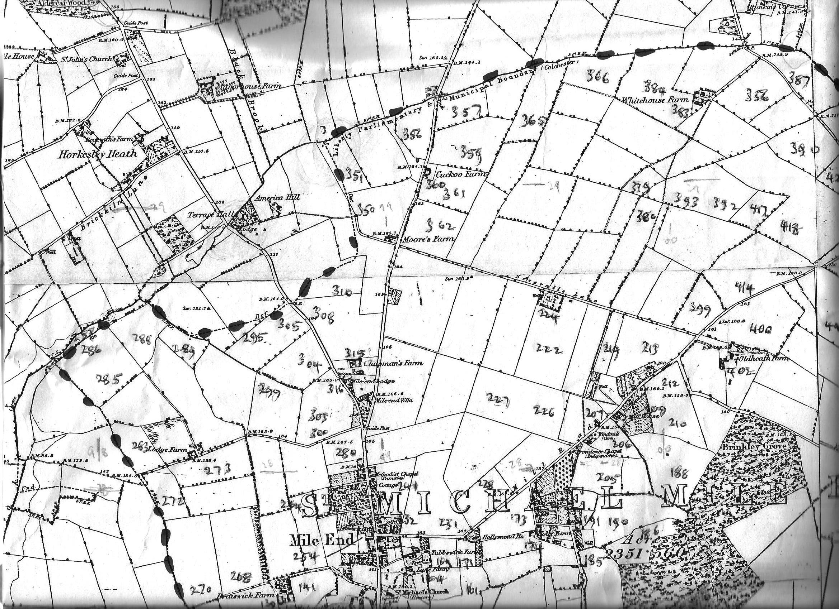
Map 1
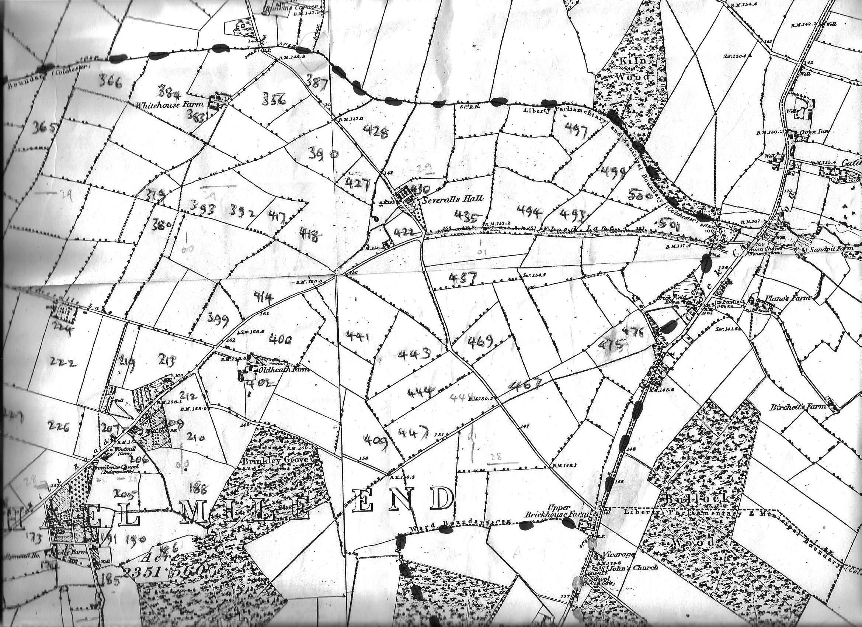
Map 2
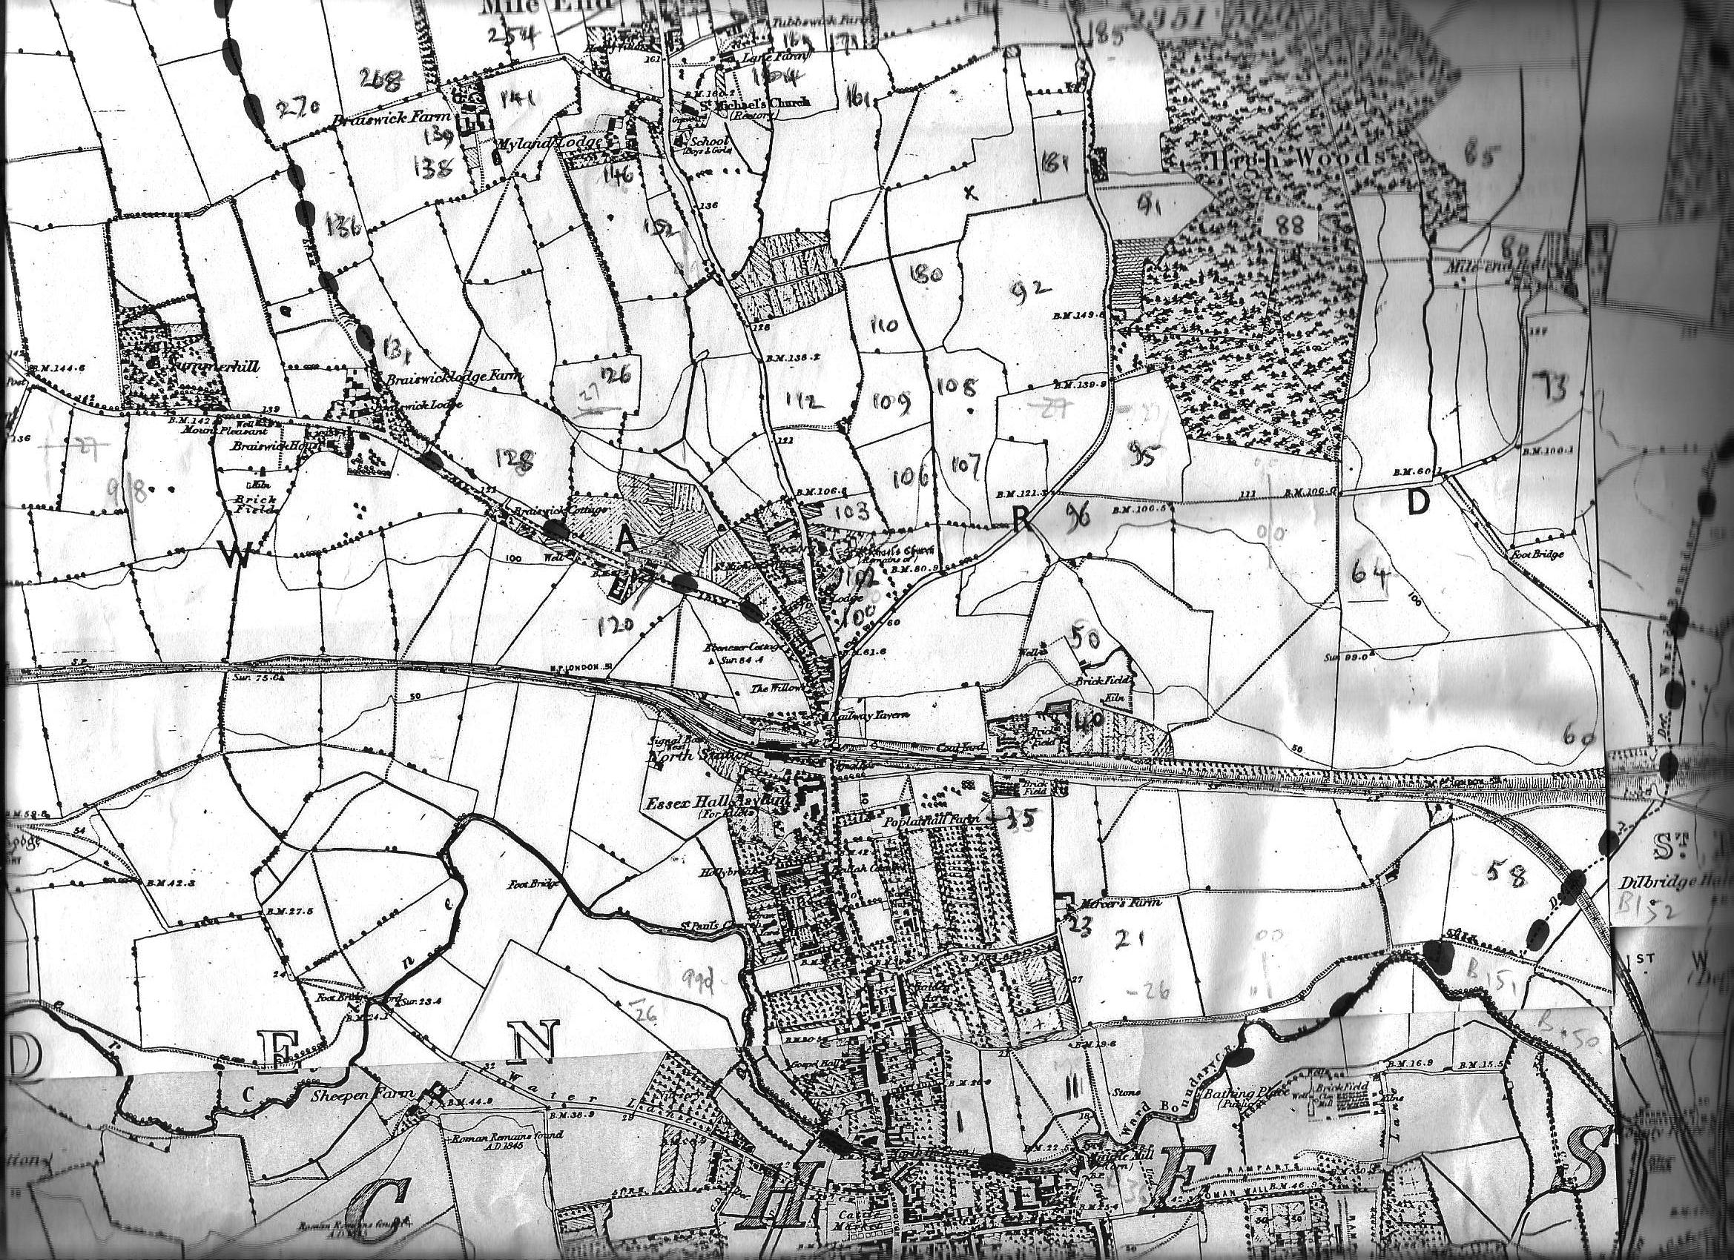
Map 3
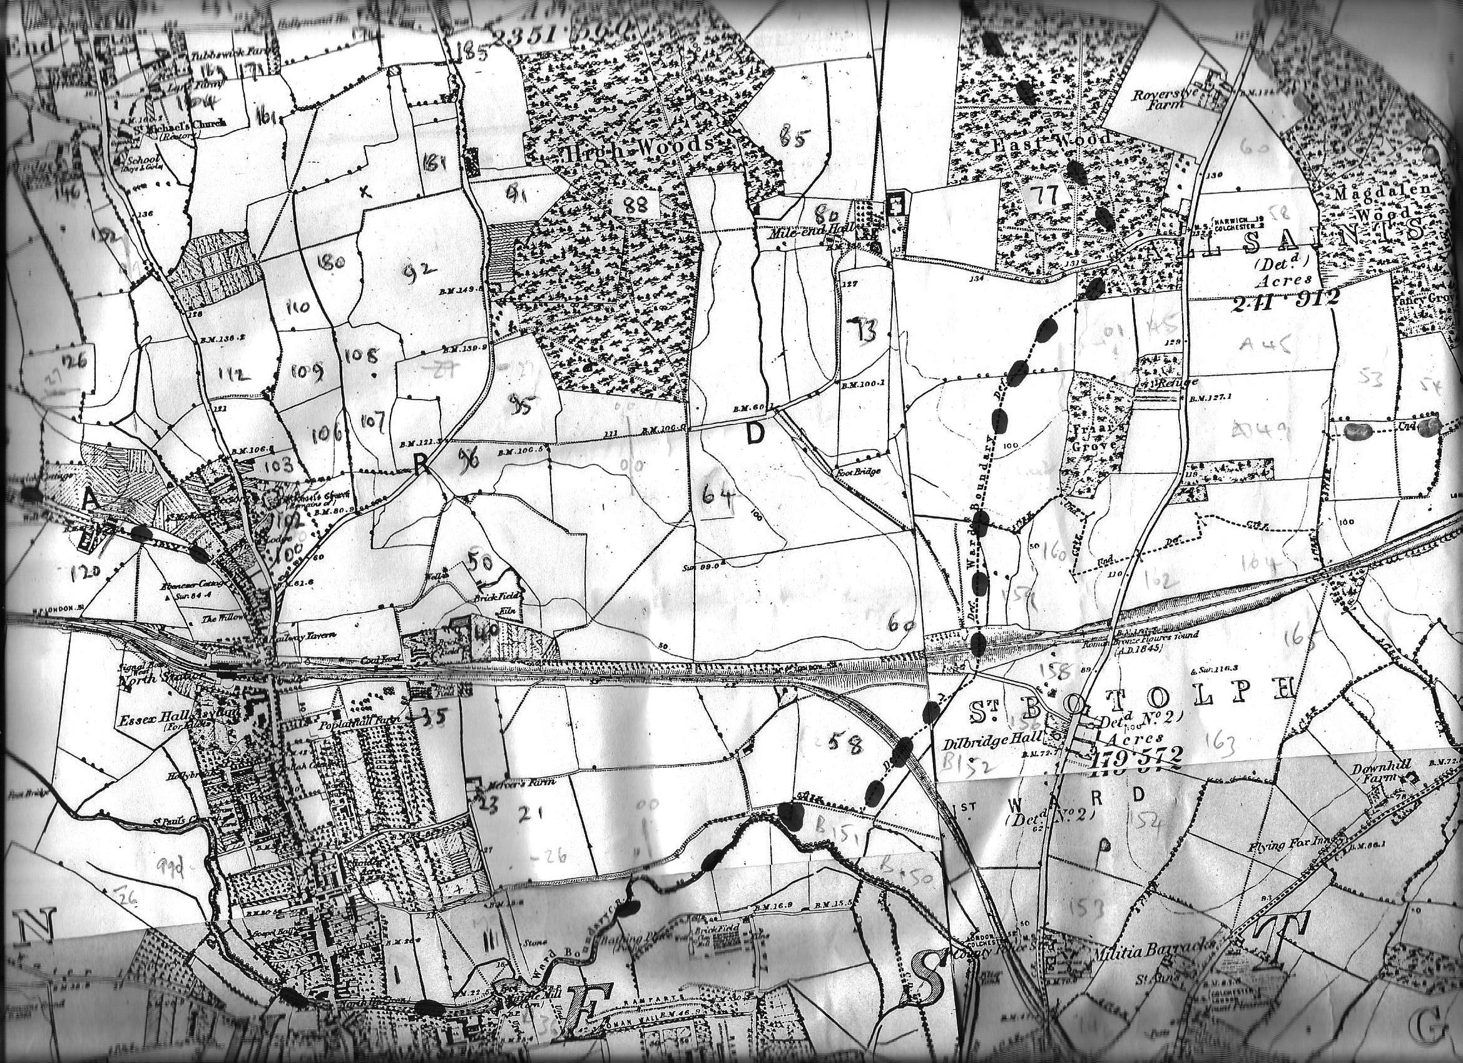
Map 4

